30th January, 2024

Dear Editors,

On behalf of myself and my co-authors, I wish to submit the manuscript entitled *‘Towards a new era of flexibility: student and staff reflections on online learning’* for consideration for publication by the International Journal of Technology in Education. The paper provides an interesting and timely insight into the strengths, challenges and lessons learned when engaging with online teaching and learning. The paper is novel in that is presents the perspectives and experiences of a large sample of both staff and students.

I confirm that this work is original and has not been published elsewhere nor is it currently under consideration for publication elsewhere. Further, I can confirm that ethical standards have been adhered to.

Thank you for receiving our manuscript. I appreciate your time and look forward to your response.

Yours sincerely,

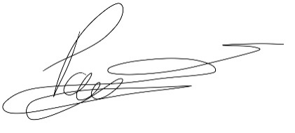

Paula C Stacey

paula.stacey@ntu.ac.uk