Bibliometric Map of Educational Robotics Studies

Abstract

The purpose of this study is to determine the general trend of research in the field of educational robotics through bibliometric analysis. 1382 papers indexed in the WOS database between 1975-2021 were subjected to bibliometric analyses. The data of the study were analyzed using VOSviwer and SciMAT. At the end of the study, it has been concluded that in the field of educational robotics the most productive country was the USA, the most influential journal was Computers and Education, the most influential author was Bers, M.U., and the most influential institution was Tufts University. It has been also concluded that computational thinking, STEM, coding, programming, social robots, and communication themes have become a trend in the field of educational robotics in recent years.

Keywords: Educational robotics, bibliometric analysis, STEM, computational thinking, programming

**Introduction**

Bibliometric studies have been increasing in recent years and studies have addressed areas related to educational technologies such as mobile learning (Hung & Zhang, 2012; Elaish et al., 2019; Sobral, 2020; Göksu, 2021; Khan & Gupta, 2021), e-learning (Tibaná-Herrera, et al., 2018; Sweileh, 2021), smart learning (Chen, et al.,2020; Agbo, et al., 2021), instructional design (Göksu, et al., 2021), learning analytics (Phillips & Özogul, 2020; Azevedo & Azevedo, 2021), and artificial intelligence (Hinojo-Lucena et al., 2014; Dhamija & Bag, 2020; Guo et al., 2020; Talan, 2021).

Bibliometric studies can be used to track trends in a subject over several years. They are often carried out with the intention of reporting scientific progress to policy makers, scientists, and other stakeholders (Ellegaard and Wallin, 2015). These studies are typically used by academics to shed light on the effectiveness of papers and journals in a topic, their interactions, and the intellectual framework for the area. Additionally, bibliometric studies enhance the area in a novel and significant way by giving scientists the knowledge they need to acquire an overview from a single point, come up with innovative research ideas, discover gaps in the literature, and position their focused contributions (Donthu et al., 2015). Bibliometric analysis is a quantitative method that provides an objective view of the literature by examining citations, common citations, etc. in the literature (Chai & Xiao, 2012). According to Cobo et al. (2011), bibliometric analysis is a set of techniques used to analyse and evaluate texts and data in substantial data sets. Bibliometric research has mostly been conducted to provide an overview of the field, and it has been seen as a reliable, objective, and cost-effective method. It was also argued that its value would gradually increase in research evaluation and management (Campbell et al., 2010). Researchers may find trend analysis helpful for identifying the most prominent journals and activities (Song, Chen, Hao, Liu, & Lan, 2019) or for determining the most influential institutions and scientists (Mair & Reischauer, 2017) in a field, as well as for deciding on the financing of the projects (Ebadi & Schiffauerova, 2016). Additionally, it can help decision-makers when deciding on educational policy by demonstrating scientific advancements in an area.

**Literature Review**

The term "robot" was coined by Karel Capek in his popular play Rossum's Universal Robots in 1920 (Spong & Vidyasagar, 2008). Robots are mechanical devices that can perform given tasks following instructions (Prayaga, Prayaga, Whiteside & Suri, 2015). The Robot Institute of America defines a robot as “a reprogrammable multifunctional manipulator designed to move material, parts, tools, or specialized devices through variable programmed motions for the performance of a variety of tasks.” (Spong and Vidyasagar, 2004:48). Robotics, on the other hand, is a technological field that deals with the construction, planning, designing, and programming of robots (Wood, 2003). Robots were first introduced to the classroom by Seymour Papert, who developed the LOGO programming language and turtle robot for children in the 1960s, and subsequently LEGO Mindstorm (Papert, 1980; 1993; Stager, 2016).

Educational robotics relates to several theories of learning. Piaget’s constructivism and Papert’s constructionism are the foundations of educational robotics. Although constructionism is based on constructivism, Papert has made some modifications to the theory (Alimisis, 2013). Papert defines constructionism as “learning by doing” (Papert and Harel, 1991). While constructivism views learning as the process of creating knowledge within oneself, constructionism suggests that the best way to learn is to create something concrete and shareable (Papert, 1993; Ackerman, 2001; Stager, 2001; 2005). Through constructionism, Papert adds the notion that when individuals develop meaningful products, they also construct new knowledge to Piaget's principle that learning is a process by which one constructs knowledge. In other words, what matters is that individuals actively participate in creating a meaningful product for themselves or others (Resnick, 1996). Papert's constructionism theory focuses on learning to learn and doing while learning, whereas Piaget's constructivism theory focuses on what individuals can be interested in and do at certain times in their life. Papert highlights the role of tools, media, and contexts in the evolution of humans (Ackermann, 2001). According to Papert, students develop knowledge more effectively when they design and construct meaningful projects, and technology facilitates this design and construction (Bers, et.al., 2002). While Piaget argues that knowledge is constructed by information in the inner world, Papert claims that technology and the use of computers also have an influence on knowledge construction (Bers, et.al., 2014). Papert suggests that children would not only learn through technology but that they will learn more fluidly through technology (Resnick, 2012).

Educational robotics draws attention with its interdisciplinary structure in the fields of science, mathematics, technology, and engineering (STEM). This interdisciplinary structure fosters students' cognitive and social skills such as research, decision-making, creative thinking, and problem-solving at all levels of education, from pre-school to university (Eguchi, 2010; Alimisis, 2013). Educational robotics provides a stimulating learning environment that promotes students' interest and curiosity (Eguchi, 2010). Furthermore, it may provide students theopportunity to engage in constructivist learning experiences also establishing a learning environment in which they can interact with real-world problems and their surroundings (Alimisis, 2013). The use of robots in education provides students a cooperative learning environment and increases their motivation (Highfield, 2010; Wei, et. Al., 2011), and may improve their technological literacy (Bers et al., 2002; Alimisis, 2013) and 21st-century skills (Talaiver & Bowen, 2010; Williams & Prejean, 2010). The studies in the literature have reported positive effects of educational robotics environments on students’ academic achievement (Huang, et.al, 2013; Chin, et.al, 2014; Özer, 2019; Şimşek, 2019), programming skills (Yolcu, 2018), achievements on STEM fields (Barker & Ansorge, 2007; Mitnik, Nussbaum & Soto, 2008; Nugent, Barker & Grandgenett, 2008), problem-solving skills (Kapa, 1999, Hussain, Lindh & Shukur, 2006; Tatlısu, 2019), computational thinking skills (Atmatzidou & Demetriadis, 2016; Constantinou & Ioannou, 2018; Papadakis & Kalogiannakis, 2022), and metacognitive awareness (Gürkez, 2021). In the case study conducted by Erdoğan et al. (2020) on pre-service teachers, it was concluded that educational robotics activities improved students' creativity, cooperation, communication and problem solving, and 21st century skills. Marín-Marín, et.al. (2020), in their semi-experimental study conducted with 177 students using the makey makey robotic device, it was concluded that the experimental method increased success, motivation, cooperation, and interaction in physical education compared to the traditional method. Moreover, it was established that the students' interest and motivation increased as a consequence of the educational robotic application employed by Bkar, et al. (2020) in geography instruction.

Bibliometric research is useful for determining general trends, collaboration, and the most effective scholars, institutions, publications, and nations in a topic, as well as guiding researchers. On the other hand, although educational robotics has become a popular topic in recent years, bibliometric studies are limited. In this sense, the purpose of this study was to find answers to the following questions about educational robotics research:

1. Which authors, institutions, countries, and journals are the most influential?

2. How have the authors collaborated in terms of authorship, nation or institution?

3. What are the most used keywords?

4. What have been the trending themes over the years?

**Method**

The researchers in this study employed bibliometric analysis to determine general trends in educational robotics research in terms of researchers, keywords, journals, nations, and citations. Bibliometrics is the statistical and mathematical representation of information in books and other forms of communication (Pritchard, 1969). Bibliometric analysis, which can be both descriptive and evaluative, is the examination of academic publications through statistical analysis based on various variables (McBurney & Novak, 2002: 40). Through bibliometric analysis, the general structure for a certain subject area can be disclosed (Çetinkaya Bozkurt & Çetin, 2016), and the researchers, institutions and scientific flow linked to the determined subject can be monitored (Martí-Parreño, et al., 2016). Bibliometric studies are useful for determining international publication rules for a topic and conducting studies in accordance with these policies (Demir & Erigüç, 2018).

**Data Collection**

The data in this study were obtained from the Web of Science database from studies published between 1975-2021. Educational robotics studies were filtered through the database. Journal papers published between 1975-2021 for educational purposes were included in the research. The inclusion criteria of the study were that it was published between 1975-2021 and was written for educational purposes. Publications other than journal papers were excluded from this study (Figure 1).

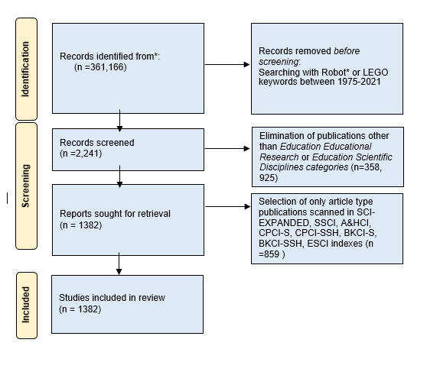

Figure 1. PRİSMA Flow Diagram

The papers published in the field of education from 1975 to December 2021 were included in the study. A total of 1382 articles were found as a result of the query, and because the Web of Science database only enables 500 publications to be downloaded at a time, four .txt files were downloaded. The items were searched in all of the available indexes.

**Data Analysis**

The VOSviewer program was used in this study to analyze co-authorship (authors, institutions, country), co-citation, and co-occurrence (keyword). Co-authorship analysis allows researchers to look into author collaboration and partnership, as well as to map the collaborations across institutions and countries (Peters and Van-Raan, 1991). Co-citation analysis, on the other hand, determines how often two publications are cited in the same publication (Small, 1973). VOSviewer, according to Van Eck and Waltman (2010), is a reasonably helpful application for bibliometric mapping and visualization. Co-authorship (authors, institutions, nation), co-citation, and co-occurrence (keyword) analyses were all carried out using the full-counting approach (Perianes-Rodriguez, et al., 2016).

The SciMAT program was also used for a more detailed examination of trending themes by years and clustering analysis in keywords. According to Cobo et al. (2012), each node in the bibliometric network displays a series of documents that are related to one another; with these data, performance analysis can be performed, the most productive and influential themes can be identified over time, and the main references in the field can be determined. The data were reduced by rearranging at an interpretable level after being obtained from the Web of Science database and imported into the SciMAT application (Cobo et al., 2012). Since the number of publications between 1982 and 2000 was very few, no theme occurred in this period. The data were analyzed in four periods as between 2000-2005, 2006-2010, 2011-2015, and 2016-2021. In order to investigate trending keywords in further depth, a strategic diagram and theme network were developed using the SciMAT program.

**Findings and Interpretation**

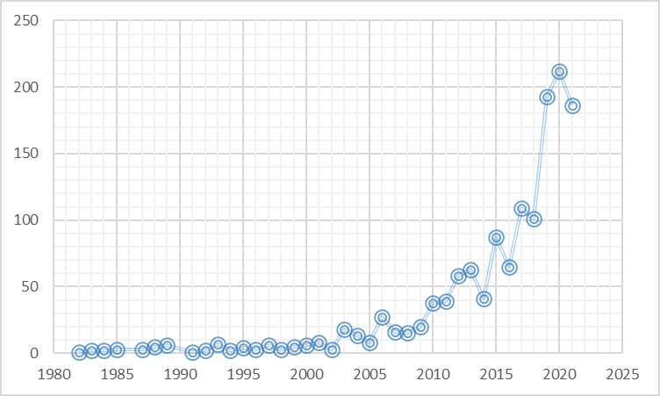

Figure 2: Distribution of the articles included in the study by years

Figure 2 illustrates the year-by-year distribution of educational robotics research papers included in this study. The number of studies in the subject of educational robotics has expanded dramatically, as shown in Figure 2. The date range between 1975 and 2021 was chosen while searching the database, however, no publications were found prior to 1982.

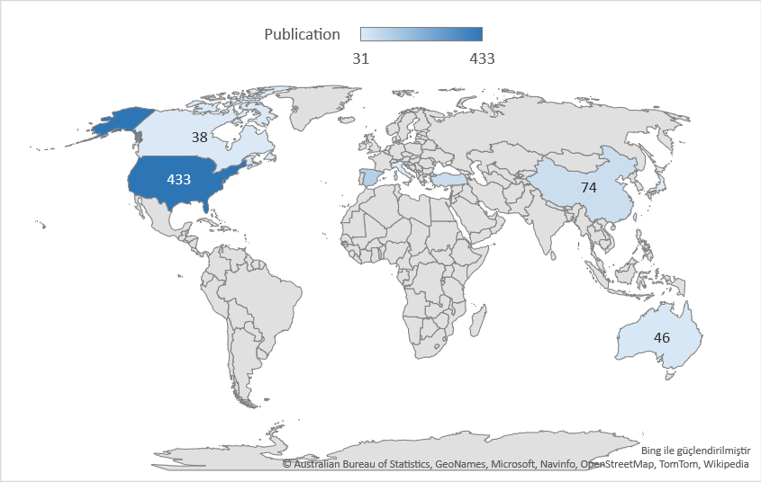

Figure 3: Distribution of studies by country

When looking at the number of papers published on the subject of educational robotics, the United States (433), Spain (126), and Turkey (79) have the most, followed by England (74), China (74), Taiwan (69), Australia (46), Canada (38), Italy (36) and Japan (31).

**Citation Analysis (Journal, Author, Institution, and Document)**

Citation analysis was used to find the most influential journals, authors, institutions, and papers in the field of educational robotics.

Table 1. The most influential journals

|  |  |  |  |
| --- | --- | --- | --- |
| **Journal** | **Number of Publications** | **Number of WOS Citations** | **Total Link Strength** |
| “Computers and Education” | 41 | 1502 | 253 |
| “International Journal of Technology and Design Education” | 40 | 609 | 191 |
| “IEEE Transactions on Education” | 109 | 2022 | 187 |
| “Journal of Science Education and Technology” | 23 | 450 | 133 |
| “International Journal of Engineering Education” | 91 | 688 | 130 |
| “Journal of Educational Computing Research” | 19 | 143 | 90 |
| “Computer Applications in Engineering Education” | 69 | 483 | 89 |
| “Education and Information Technologies” | 37 | 168 | 88 |
| “Educational Technology & Society” | 18 | 424 | 82 |
| “Interactive Learning Environments” | 26 | 162 | 82 |

Table 1 shows that, while *IEEE Transactions on Education* and the *International Journal of Engineering Education* have the most publications (109 and 91 publications respectively), *Computers and Education* and the *International Journal of Technology and Design Education* have the most citations and the highest number of links.

Table 2. The most influential authors

|  |  |  |  |  |  |
| --- | --- | --- | --- | --- | --- |
| **Author** | **Number of Publications** | **Number of Wos Citations** | **Total Number of Links** | **Institution** | **Country** |
| Bers, Marina Umaschi | 17 | 611 | 69 | Tufts University | USA |
| Sullivan, Amanda | 12 | 534 | 65 | Tufts University | USA |
| Jung, Sung Eun | 5 | 8 | 27 | Arizona University | USA |
| Iee, Kyung Hwa | 5 | 8 | 27 | The University of Georgia, | USA |
| Bernstein, Debra | 5 | 4 | 9 | Pittsburgh Univ. | USA |
| Zhong, Baichang | 7 | 25 | 8 | South China Normal University | China |
| Verner, Igor M. | 8 | 45 | 6 | Technion-Israel Institute of Technology | Israel |
| Chen, Nian-shing | 8 | 159 | 4 | National Taiwan Normal University | Taiwan |
| Kim, Yanghee | 5 | 31 | 3 | Northern Illinois University | USA |
| Romero, Margarida | 5 | 2 | 2 | Université Côte d'Azur | France |

As shown in Table 2, the most influential authors are Marina Umaschi Bers and Amanda Sullivan in terms of number of publications, number of WOS citations, and total links. Among the most cited publications in Table 4, "Computational thinking and tinkering: Exploration of an early childhood robotics curriculum" and "Robotics in the early childhood classroom: learning outcomes from an 8-week robotics curriculum in pre-kindergarten through second grade", which ranks first and 9th respectively, are both published by these two authors.

Table 3. The most influential institutions

|  |  |  |  |  |
| --- | --- | --- | --- | --- |
| **Institution** | **Country** | **Number of Publications** | **Number of Citations** | **Number of Links** |
| Tufts University | USA | 27 | 1005 | 551 |
| University of Georgia | USA | 16 | 182 | 161 |
| National Central University | Taiwan | 12 | 321 | 156 |
| Massachusetts University | USA | 6 | 255 | 120 |
| National Sun Yat-Sen Univ. | Taiwan | 8 | 159 | 98 |
| National Taiwan Normal Univ. | Taiwan | 13 | 99 | 94 |
| South China Normal Univ. | China | 7 | 25 | 91 |
| Technion Israel Inst Technology | Israel | 12 | 115 | 85 |
| Wyoming Univ | USA | 5 | 87 | 81 |
| Miami University | USA | 4 | 135 | 80 |

Tufts University, University of Georgia, and National Central University are the most influential institutions in the field of educational robots, according to Table 3. Table 3 further shows that the majority of the institutions are in the United States and Taiwan. The United States is the country with the most publications, as seen in Figure 3.

Table 4. Most cited publications

|  |  |  |  |  |
| --- | --- | --- | --- | --- |
| **Article** | **Authors** | **Publication Year** | **Source** | **Wos Number of Citation** |
| “Computational thinking and tinkering: Exploration of an early childhood robotics curriculum” | Bers, Marina Umaschi; Flannery, Louise; Kazakoff, Elizabeth R.; Sullivan, Amanda | 2014 | Computers & Educatıon | 262 |
| “Virtual laboratories for education in science, technology, and engineering: A review” | Potkonjak, Veljko; Gardner, Michael; Callaghan, Victor; Mattila, Pasi; Guetl, Christian; Petrovic, Vladimir M.; Jovanovic, Kosta | 2016 | Computers & Educatıon | 251 |
| “Exploring the Possibility of Using Humanoid Robots as Instructional Tools for Teaching a Second Language in Primary School” | Chang, Chih-Wei; Lee, Jih-Hsien; Chao, Po-Yao; Wang, Chin-Yeh; Chen, Gwo-Dong | 2010 | Educatıonal Technology & Socıety | 139 |
| “Hands-on experiences of undergraduate students in Automatics and Robotics using a virtual and remote laboratory” | Jara, Carlos A.; Candelas, Francisco A.; Puente, Santiago T.; Torres, Fernando | 2011 | Computers & Educatıon | 124 |
| “New Pathways into Robotics: Strategies for Broadening Participation” | Rusk, Natalie; Resnick, Mitchel; Berg, Robbie; Pezalla-Granlund, Margaret | 2008 | Journal Of Scıence Educatıon And Technology | 111 |
| “Virtual and remote robotic laboratory: Comparative experimental evaluation” | Tzafestas, Costas S.; Palaiologou, Nektaria; Alifragis, Manthos | 2006 | IEEE Transactıons On Educatıon | 110 |
| “Robotics and science literacy: Thinking skills, science process skills and systems understanding” | Sullivan, Florence R. | 2008 | Journal Of Research In Scıence Teachıng | 109 |
| “Assessing elementary students' computational thinking in everyday reasoning and robotics programming” | Chen, Guanhua; Shen, Ji; Barth-Cohen, Lauren; Jiang, Shiyan; Huang, Xiaoting; Eltoukhy, Moataz | 2017 | Computers & Educatıon | 106 |
| “Robotics in the early childhood classroom: learning outcomes from an 8-week robotics curriculum in pre-kindergarten through second grade” | Sullivan, Amanda; Bers, Marina Umaschi | 2016 | Internatıonal Journal Of Technology And Desıgn Educatıon | 103 |
| “Storytelling by a kindergarten social assistive robot: A tool for constructive learning in preschool education” | Fridin, Marina | 2014 | Computers & Educatıon | 103 |

According to Table 4, the most cited publication is “Computational thinking and tinkering: Exploration of an early childhood robotics curriculum” by Bers, Flannery, Kazakoff & Sullivan (2014). As shown in Table 4, it is clear that studies are conducted at all levels of education, from pre-school to higher education, and in subjects such as science, engineering, technology, language education, and programming. Accordingly, it is possible to say that educational robotics research is carried out with students of all levels and in a variety of subjects. Furthermore, half of the papers were published in the journal Computers and Education. Table 2 shows that Computers and Education is the most referenced journal.

**Co-author Analysis (Author, Institution, Country)**

In the bibliometric map, 404 out of 3858 writers satisfied the requirement of having at least two papers published together in order to determine the authors' partnership, and four clusters were generated. In bibliometric maps, the size of the circles represents the number of articles while the thickness and frequency of the links indicate the rate of cooperation. As shown in Figure 4, it is clear that the partnership between the authors is weak because the circles are far from each other, and the links are weak.

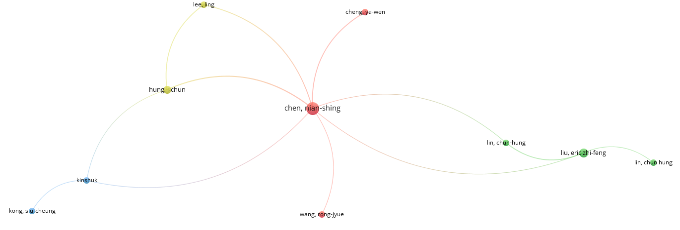

Figure 4. Co-author (author) analysis

As shown in Figure 4, it is seen that in the first cluster (red) Nian-Shing Chen (7 links, TLS=11) is located in the center of the map. Other authors in the first cluster are Ya-wen Cheng (1 link, TLS=2) and Rong-Jyue Wang (1 link, TLS=1).

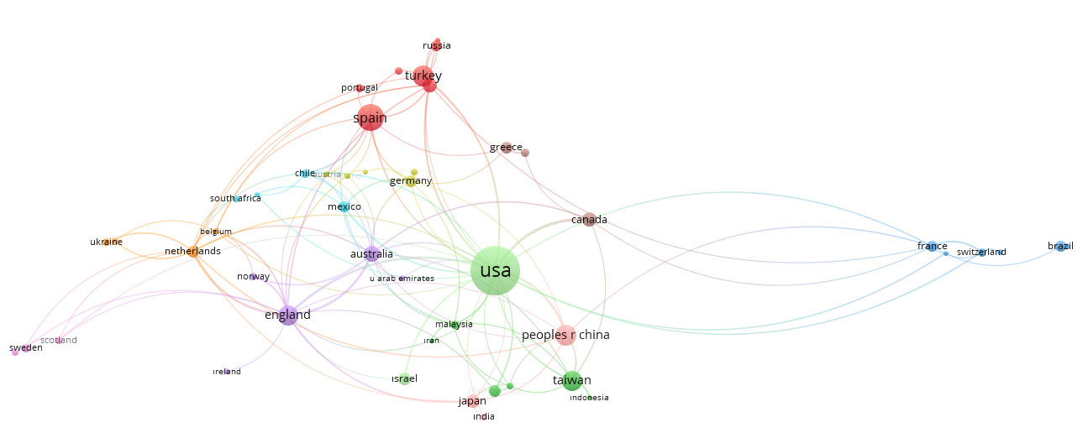

Figure 5. Co-author analysis (Country)

Figure 5 shows that on the map constructed with the requirement of having at least 5 common publications, 49 of the 81 countries met this requirement, resulting in 11 clusters. The countries with the most partnerships include the United States (27 links, TLS=66), England (16 links, TLS=38), and the Netherlands (14 links, TLS=25). The size of the circles on the bibliometric map represents the number of publications, while the links represent the frequency of the partnership. Therefore, the countries with the most publications are the United States (416), Spain (126), and Turkey (79). Spain (11 links, TLS=16), Italy (9 links, TLS=14), and Turkey (3 links, TLS=6) are the countries with the most partnerships in the first cluster (red). When other clusters are examined, it is seen that the most influential countries are Taiwan (7 links, TLS=11) in the second cluster (green), France (7 links, TLS=11) in the third cluster (blue), Germany (9 links, TLS=12) in the fourth cluster (yellow), England (16 links, TLS=38) in the fifth cluster (mauve), Mexico and Chile (7 links, TLS=10) in the sixth cluster (turquoise), the Netherlands (14 links, TLS=25) in the seventh cluster (orange), Canada (5 links, TLS=13) in the eighth cluster (purple), Scotland and Sweden (4 links, TLS=4) in the ninth cluster (dark pink), China (9 links, TLS=19) in the tenth cluster (light pink) and the United States (27 links, TLS=66) in the eleventh cluster (light green).

In the co-authorship analysis, which was carried out to determine the partnership between institutions and was created on the condition of having at least 3 joint publications, 175 of 1936 institutions met this condition and a total of 12 clusters were formed (Figure 6).

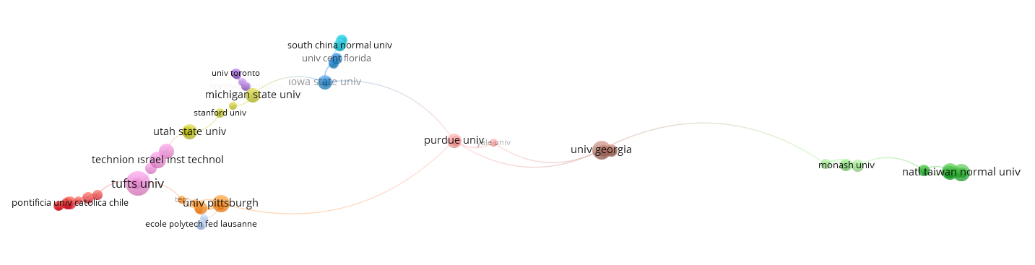

Figure 6: Co-author Analysis (Institution)

As shown in Figure 6, Carnegie Mellon University (5 links, TLS=10), University of Georgia (6 links, TLS=10), and Pittsburgh University (6 links, TLS=10) are the institutions with the most partnerships. The institutions with the most publications are Tufts University, Santo Tomas University, and University of Georgia. Barcelona University (4 links, TLS=4) is the most influential institution in the first cluster (red) consisting of 10 institutions in total. The institutions with the most partnerships are National Sun Yat University and National Yunlin University Science and Technology (4 links, TLS=5) in the second cluster (green), Iowa State University (6 links, TLS=6) in the third cluster (blue), Utah State University in the fourth cluster (yellow), York University (4 links, TLS=5) in the fifth cluster (purple), Cent China Normal University (4 links, TLS=4) in the sixth cluster (turquoise), Pittsburgh University (6 links, TLS=10) in the seventh cluster (orange), University of Georgia (6 links, TLS=10) in the eighth cluster, Tufts University (4 links, TLS=4) in the ninth cluster, and Purdue University (6 links, TLS=7) in the tenth cluster (pink).

**Co-occurrence Analysis (Keyword)**

As shown in Figure 7, 135 out of 3334 keywords satisfied the requirement of being together in at least 5 publications. In Figure 7, it is seen that the concepts of robotics, computational thinking, and programming are located at the center of the map and are trending.

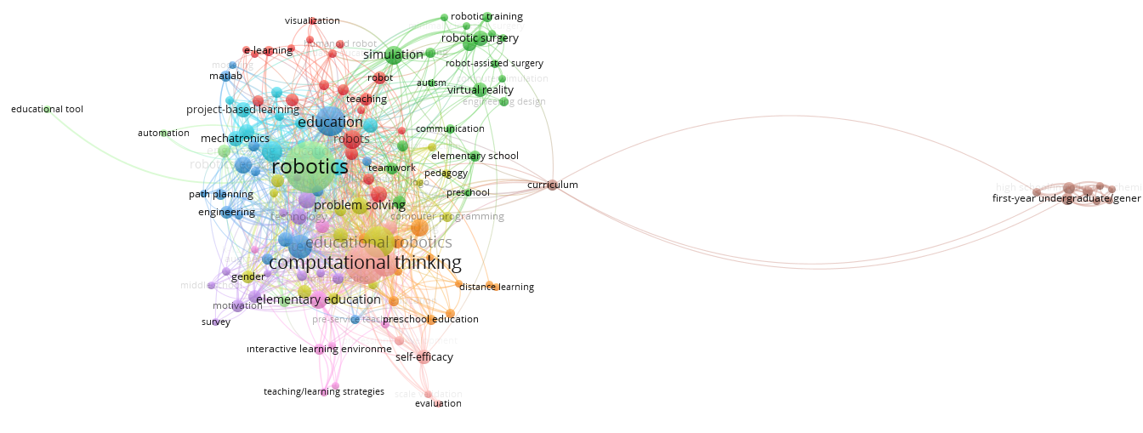

Figure 7: Co-occurrence Analysis (Keyword)

According to Figure 7, the most used keywords are robotics (96 links, TLS=306), computational thinking (66 links, TLS=227), programming (44 links, TLS=136), educational robotics (57 links, TLS=129), education (55 links, TLS=120), STEM (34 links, TLS=94), coding (TLS=61), elementary education (TLS=60), robots (36 links, TLS=54), engineering education (TLS= 54), educational technology (TLS=48), problem-solving (26 links, TLS=48), and early childhood education (TLS=40). As shown in Figure 7, the concepts of robotics, computational thinking, educational robotics, STEM, programming have been trending in recent years.

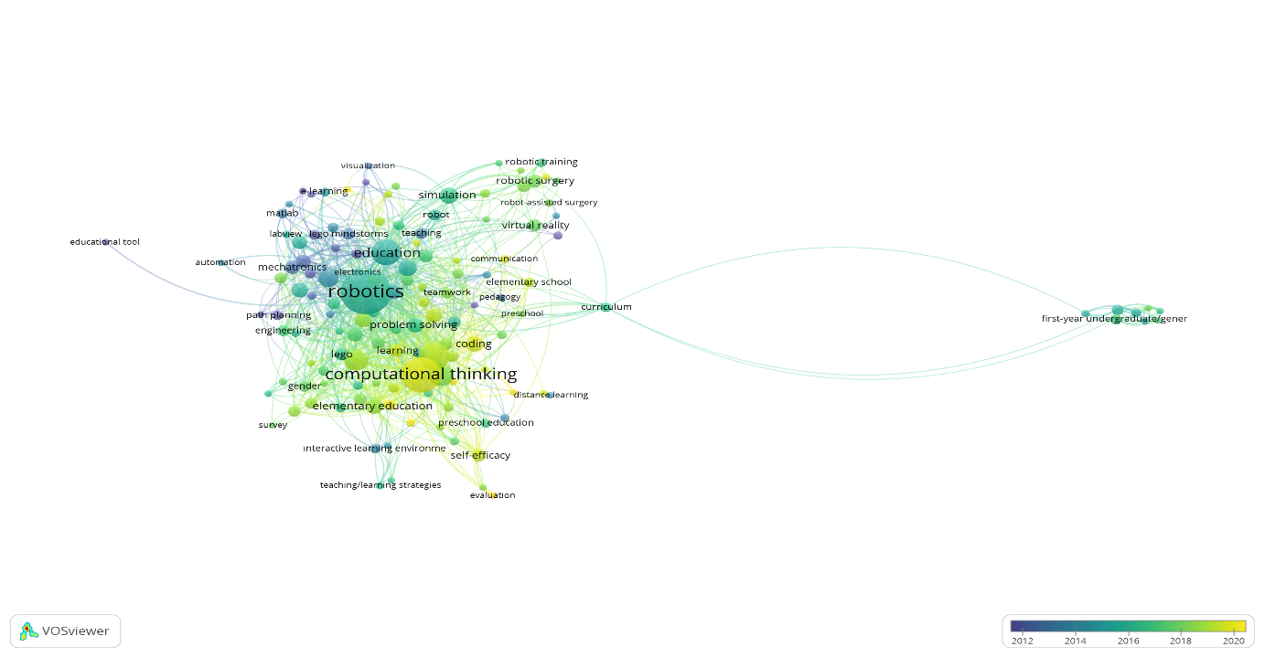

Figure 8: Recently trending keywords

Seven motor clusters emerged in the strategic diagram, which was created in order to discover the trending themes used in recent years and included in at least four publications. In the strategic diagram, the intensity increases as you move up, and the centrality increases as you move to the right. Computational thinking is the strongest theme in terms of both intensity and centrality in the strategic diagram constructed for the studies conducted from 2016 to 2021. Other motor clusters include STEM, surgical skills, social robots, communication, experiences, and self-efficacy. Project-based learning, game-based learning, early childhood, embodied-argumentation themes are basic and transversal themes, autonomous robot, cognitive skills, classroom, mobile application, collaborative/cooperative learning, secondary education, and embodied argumentation are emerging or declining themes, higher education, remote, MATLAB, e-learning and learning environment are isolated clusters. The motor clusters that emerged between 2016 and 2021 are not the same as those that emerged previously, indicating that there is a growing interest in educational robotics research and publications from various disciplines, as well as the subject's growing relevance. The themes of autonomous robot, cognitive skills, classroom, mobile application, collaborative/cooperative learning, secondary education, and embodied argumentation, which represent emerging or declining themes, exemplify relatively less studied topics that are strong in the period but weakly related to other thematic fields. Higher education, remote learning, MATLAB, e-learning, and learning environment are isolated themes that have not yet been sufficiently researched, yet they are strong themes in the period.

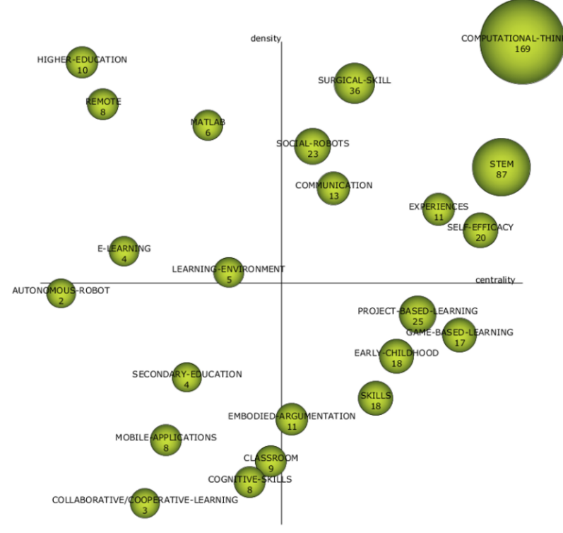

Figure 9: Strategic Diagram for 2016-2021

The keywords in the clusters for the years 2016-2021 are listed in Table 5. The circles in the strategic diagram are directly proportional to the number of publications in the theme. In the strategic diagram, centrality increases as you move to the right, while intensity increases as you move up (Cobo et al., 2012). The motor clusters are situated in the upper right corner of the strategic diagram, and they contain the themes with the highest centrality and intensity. The basic and transversal clusters are found in the lower right corner and have a high centrality but low intensity. In the upper left corner, there are highly developed and isolated clusters, while in the lower-left corner, there are emerging or declining clusters (Cobo, et al., 2015). When the keywords are evaluated, computational thinking, surgical skills, STEM, and programming emerge as the most prominent. As shown in Table 5, educational robotics studies are conducted at all levels of education, from pre-school to higher education. STEM, medicine, programming, coding, and engineering are the most studied subjects. In addition, human-robot interaction, child-robot interaction, collaborative learning, group learning, task-based learning, project-based learning, game-based learning, communication, self-efficacy, and effects on 21st-century skills are among the other issues that have been prominent in recent years.

Table 5. Keywords used in the clusters between 2016-2021

|  |  |  |  |  |
| --- | --- | --- | --- | --- |
| Clusters | Documents | h-index | Citations | Keywords |
| Computational-Thinking | 169 | 20 | 1426 | Educational Robotics, elementary schools, Robotic-coding, computational thinking, K-12, programming |
| Surgical-Skill | 36 | 10 | 274 | Achievement, surgical-skills, laparoscopic, medical, simulation-based-learning, virtual-reality |
| STEM | 87 | 16 | 791 | STEM, Inquiry-based learning, education, engineering, mathematics-education, Technology In Education |
| MATLAB | 6 | 3 | 131 | Robotics-education, manipülatör, kinematic, model-based learning, virtual environments, MATLAB |
| Higher-Educatıon | 10 | 3 | 53 | Laboratory instructions, representation, learning-outcomes, hands-on ability, higher education, chemistry |
| Social-Robots | 23 | 5 | 102 | Social robots, gestures, behavior, child-robot interactions, foreign language, childhood education |
| Remote | 8 | 2 | 21 | Distance learning, telepresence robot, internet of things, online, remote, smart learning environments |
| Communicatıon | 13 | 5 | 81 | Constructivism, Autism spectrum disorder, intervention, communication, social-competencies, team-learning |
| Learnıng-Environment | 5 | 4 | 40 | Learning environment, human-robot interactions, perspective, 21st Century skills, augmented reality, interactive environments |
| Self-Effıcacy | 20 | 4 | 78 | Attitudes, teacher’s perception, pre-service teacher education, scales, ability, self-efficacy |
| E-Learning | 4 | 1 | 4 | E-learning, intelligent robot, learning analytics, digital competencies, generation, automated-assessment |
| Project-Based-Learning | 25 | 7 | 176 | Students, LEGO, experiential, learning, mechanical engineering, Project-based learning |
| Experiences | 11 | 4 | 282 | Thinking, face, careers, surveys, design, experiences |
| Game-Based-Learnıng | 17 | 6 | 88 | Tools, gender differences, meta-analysis, game-based learning, problem-based learning, motivation |
| Early-Childhood | 18 | 8 | 193 | Framework, schools, pre-school education, early childhood, kindergarten, literacies |
| Embodied-Argumentation | 11 | 4 | 70 | Environment, robots, agents, challenges, embodied argumentation, physics |
| Skills | 18 | 7 | 174 | Skills, teaching/learning strategies, systems-thinking, curriculum, gender, primary education |
| Secondary-Educatıon | 4 | 2 | 11 | Humanoid robots, Robotic curriculum, ICT, secondary education, TAM, Active learning |
| Mobile-Applications | 8 | 3 | 34 | Mobile applications, algorithmic skills, interdisciplinarity, open-learning, TPACK, Ardunio |
| Cognıtive-Skılls | 8 | 5 | 45 | Systems, instructions, competencies, artificial intelligence, cognitive skills, task-based learning |
| Classroom | 9 | 3 | 53 | Perceptions, classroom, computer-aided learning, human-computer interaction, maker-education, educational technology |
| Collaboratıve/Cooperatıve-Learnıng | 3 | 1 | 5 | Board games, collaborative-cooperative learning, health-care education, middle grades |
| Autonomous-Robot | 2 | 1 | 1 | Autonomous robot, digitalization, resident |

As shown in Figure 10, it is seen that 44 keywords were formed in the 2000-2005 period and 32 were used in the 2006-2010 period as well, 100 keywords were used in the 2006-2010 period and 87 were used in the 2011-2015 period as well, 171 keywords were used in the 2011-2015 period and 163 of them were sustained to the 2015-2021 period, and 234 keywords were used in the 2016-2021 period. As shown in Figure 10, the number of keywords used in the field of educational robotics continues to increase. In this case, it can be said that the variety of topics, studies in different fields, and the number of publications are constantly increasing.

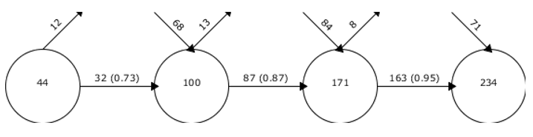

Figure 10. Keyword Overlapping Map

Regarding the examination of the topics according to historical periods, a longitudinal map is provided. Solid lines represent themes that share the same keyword, whereas dashed lines suggest common keywords that are not the same as the theme names. The thickness of the lines is proportionate to the link between the topics (Murgado-Armenteros, et al., 2015). In the periodical analysis of educational robotics studies, emerging clusters are "education" between 2000 and 2005, "competition", "intelligent robot", "matlab", and "curriculum" between 2006 and 2010, "classroom", and "achievement" between 2011 and 2015, "mechanical engineering”, “virtual environment”, “communication, “game-based learning”, “LEGO”, “education”, “skills”, “tools”, “artificial intelligence”, “computational thinking”, “STEM”, “surgical skills”, “social robots”, “communication”, “experiences”, “self-efficacy”, “project-based learning”, “game-based learning”, “early childhood”, “embodied-argumentation”, “autonomous robot”, “cognitive skills”, “classroom”, “mobile application”, “collaborative/cooperative learning”, “secondary education”, “embodied argumentation”, “higher education”, “remote”, “MATLAB”, “e-learning”, and “learning environment” between 2016 and 2021. In Figure 11, the thickness of the lines represents the intensity of the relationship between the clusters, and the size of the circles represents the number of studies. Dashed lines indicate that different keywords are used in the cluster, while solid lines indicate that the cluster name is also a keyword.

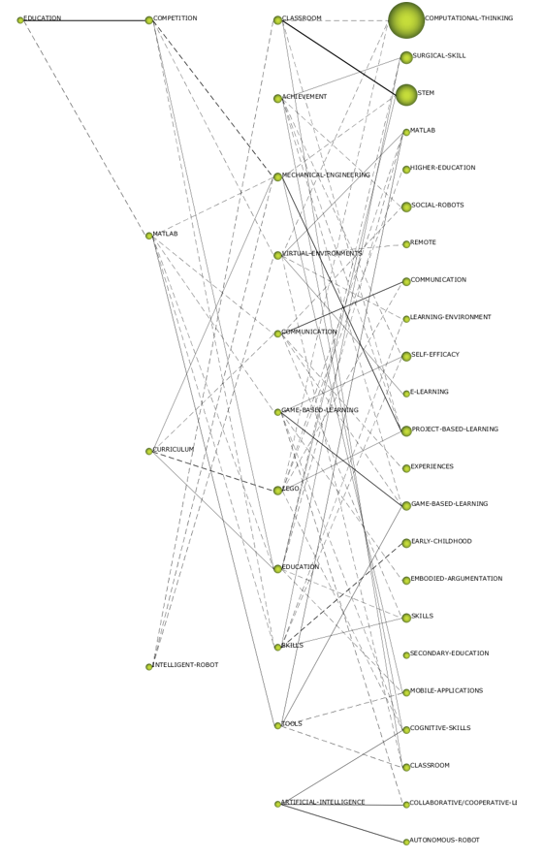

Figure 11: Thematic analysis of the years 2000-2005, 2006-2010, 2011-2015, 2016-2021

**Bibliographic Coupling Analysis**

In order to examine the frequency of being cited together in similar publications, the minimum number of publications is determined as 5. As shown in Figure 12, 15 of 3858 authors this condition of being cited together in at least 5 publications, resulting in a total of 3 clusters, and the largest cluster being the red cluster. In the figure, the size of the circles indicates the number of publications, and the thickness of the lines indicates the status of being cited in similar publications.

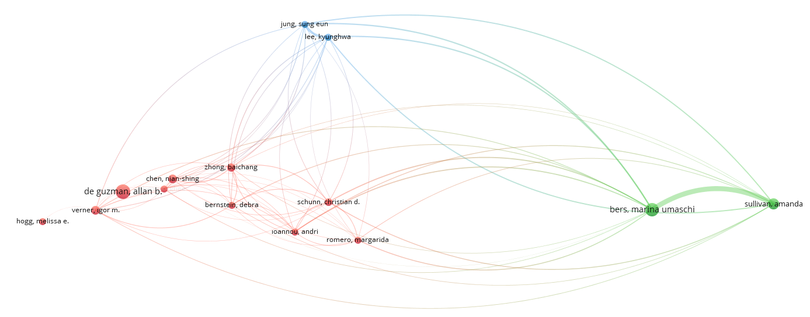

Figure 12: Bibliographic Coupling

In Figure 12, it is seen that the authors are generally located far from the center and each other. This situation indicates that high-intensity clusters are not formed due to the diversity of subjects studied in the field of educational robotics. According to the figure, the strongest relationship is between Marina Umaschi Bers (11 links, TLS=2018) and Amanda Sullivan (10 links, TLS=1844). Sun Eun Jung (8 links, TLS=641), Kyung Hwa Iee (8 links, TLS=641), Christian D. Schunn (85 links, TLS=270), Adri Ioannou (50 links, TLS=237), Baichang Zhong (25 links, TLS=221), and Debra Bernstein (54 links, TLS=192) are the most cited authors in other similar publications.

**Conclusion and Discussion**

The number of educational robotics studies and the number of keywords on the Web of Science database between the years 1975-2021 have increased. In this case, it can be claimed that the variety of topics, studies in different fields, and the number of publications have been constantly increasing. When the literature was examined, it has been concluded that there has been a significant increase in the studies in the field of educational robotics over time (Anwar, Bascou, Menekse & Kardgar, 2019; Yang, Liu & Chen (2020, López-Belmonte, Segura-Robles, Moreno-Guerrero & Parra-González, 2021).

When the articles published in the field of educational robotics were examined, it was observed that most publications were conducted in the USA, Spain, and Turkey, followed by England, China, Taiwan, Australia, Canada, Italy, and Japan. In the co-authorship (country) analysis, it was concluded that the USA, England, and the Netherlands were the countries with the most partnerships. In the first cluster, Spain, Italy, and Turkey were the countries with the most partnerships. In the bibliometric study of robotics research in education conducted by Yang, Liu, and Chen (2020) for the years 2009-2019, it has been determined that the USA, Taiwan, and China were the countries with the most publications. In a study by López-Belmonte et al. (2021), the USA, Spain, and Italy were determined as the most productive countries.

At the end of the study, it has been determined that the most frequently published journals were IEEE Transactions on Education and the International Journal of Engineering Education, while the most cited journals were Computers and Education and the International Journal of Technology and Design Education. It was also concluded that the most influential authors in the field of educational robotics were Marina Umaschi Bers and Amanda Sullivan in terms of number of publications, number of WOS citations, and TLS. Lopez-Belmonte et al. (2020) also determined Marina Umaschi Bers as one of the most influential authors. These two authors also published the articles "Computational thinking and tinkering: Exploration of an early childhood robotics curriculum" and "Robotics in the early childhood classroom: learning outcomes from an 8-week robotics curriculum in pre-kindergarten through second grade” among the most cited publications. As a result of the co-authorship (author) analysis, it was observed that three clusters were formed and were located in the center of the map in the first cluster. Nian-Shing Chen was also among the 10 most influential authors. As a result of the co-authorship analysis, it can be said that the clusters and the partnership between the authors were weak. In the bibliographic coupling analysis, the authors who were cited together in the publications the most were Bers, M. U. and Sullivan, A. This may be because the two authors co-authored the two most cited publications in the field. Bers and Sullivan work together at Tufts University explain their co-authorship, Tufts' US location adds to that country's influence, and their focus on early childhood robotics reports why it's a trending keyword.

It was concluded that the institutions with the most publications and citations in the field of educational robotics were Tufts University and University of Georgia. In the analysis of the ten most influential institutions in the field, it was observed that the institutions were mostly located in the USA and Taiwan. As a result of the co-author (institution) analysis, Carnegie Mellon University, University of Georgia, and Pittsburgh University are the institutions with which the authors publishing in the field collaborate the most. Lopez-Belmonte et al. (2020), on the other hand, University of Georgia, Tufts University, and State University System of Florida were determined as the institutions that publish the most.

As a result of the clustering analysis made with VOSviwer, the most used keywords in the field of educational robotics were robotics, computational thinking, programming, educational robotics, education, STEM, coding, elementary education, robots, engineering education, educational technology, problem-solving, and early childhood education. It has been concluded that the concepts of robotics, computational thinking, educational robotics, STEM, programming were trending in recent years. A strategic diagram was created to examine the trending themes used in recent years in more detail, and it was concluded that the keyword "computational thinking" was the strongest theme in terms of both density and centrality between 2016-2021. As a result of the studies conducted in the field of educational robotics, Yang, Liu & Chen (2020) and López-Belmonte et al. (2021) also concluded that computational thinking was the strongest theme. Denning and Tedre (2019) defined the concept of computational thinking as “*the mental skills and practices for designing computations that get computers to do jobs for us and explaining and interpreting the World as a complex of information process*”. It has been concluded that the keywords of STEM, surgical skills, social robots, communication, experiences, self-efficacy were other motor clusters. As a result of the bibliometric research conducted on STEM research by Marín-Marín, et al. (2021), it has been concluded that computational thinking, robotics, and programming were among the prominent themes recently. In the systematic review study of educational robotics research by Talan (2020), the most used keywords were determined as robotics, STEM, programming, coding, and success. In addition, according to studies, robotic technology is frequently used in medical education to develop surgical skills (Oleynikov,2008; Diana & Marescaux, 2015; Romero, De La Hoz & González,2019). On the other hand, social robotics is described as robots that interact and communicate with humans and with themselves, and it has lately become a popular concept (Ge & Matari'c, 2009; Mejia, & Kajikawa, 2017). When the literature was examined, it has been concluded that educational robotics applications improved students' communication skills, as well (Erdoğan, Toy, & Kurt, 2020; Marín-Marín et al., 2020). In addition, Velásquez-Angamarca et al. (2019) concluded that robotic applications had positive effects on students with communicative disorders. In the studies between 2016 and 2021, the themes of project-based learning, game-based learning, early childhood, embodied argumentation were basic and transversal themes (high centrality but low intensity); autonomous robot, cognitive skills, classroom, mobile application, collaborative/cooperative learning, secondary education, and embodied argumentation were emerging or declining themes (subjects that are strong in the period but weakly related to other thematic areas and have been relatively less studied); and higher education, remote, MATLAB, e-learning, and learning environment were isolated clusters (not studied enough yet, but strong themes in the period). In addition, when the keywords used in the clusters were examined, it was seen that educational robotics studies were included in all education levels from pre-school to higher education. STEM, medicine, programming, coding, and engineering, and mathematics were the most studied areas. As a result of the research conducted by Talan (2020), it was concluded that educational robotics studies were mostly conducted in the fields of algorithm and programming, science, mathematics, and language education. In addition, human-robot interaction, child-robot interaction, collaborative learning, group learning, task-based learning, project-based learning, game-based learning, communication, self-efficacy, and its effects on 21st-century skills were among the other issues that have been prominent in recent years. In the study conducted by Lopez-Belmonte (2021), it was concluded that the themes of computational thinking, programming, robotic surgery were the most influential themes in recent years. As a result of the systematic review study conducted by Xia & Zhong (2018) on the use of educational robotics applications at the K-12 level, it has been concluded that robotic applications were used at all levels, especially in primary school. As a result of the research conducted by Kaya, Korkmaz & Çakır (2020), it was concluded that gamified robotics activities contributed positively to students' computational thinking and problem-solving skills. When the literature was examined, it was seen that educational robotics applications in the STEM field made significant contributions to students' STEM skills (Acar et al., 2019). As a result of the research conducted by Güleryüz (2020), it was concluded that educational robotic applications significantly affected pre-service teachers' 21st-century skills and attitudes towards science, and also made the lessons more fun.

The findings of this study suggest that nations with less research in the area of educational robots may need to call for research. In addition, ideas can be exchanged with the most influential authors in the field of educational robotics, Bers and Sullivan. The work of other well-known researchers can also be followed by scholars. Future studies can focus on contemporary trend themes such as computational thinking, programming, STEM, coding, early childhood education, robotics, engineering education, educational technology, problem-solving, and primary education.

**References**

Acar, B., Korkmaz, Ö., Çakır, R., Erdoğmuş, F. U., Çakır, E. (2019). *The Effects of Educational Robot Sets and Simple Machines in Secondary School 7th Grade Science and Technology Lesson on Basic Skill Levels and Attitudes Towards the Lesson*. 1st International Contemporary Education and Social Sciences Symposium, 76.

Ackermann, E. (2001). Piaget’s constructivism, Papert’s constructionism: What’s the difference. *Future of Learning Group Publication*, 5(3), 438.

Agbo, F. J., Oyelere, S. S., Suhonen, J., & Tukiainen, M. (2021). Scientific Production And Thematic Breakthroughs In Smart Learning Environments: A Bibliometric Analysis. *Smart Learning Environments*, 8(1), 1-25.

Alimisis, D. (2013). Educational Robotics: Open Questions and New Challenges. *Themes In Science And Technology Education*, 6(1), 63-71.

Anwar, S., Bascou, N. A., Menekse, M., & Kardgar, A. (2019). A Systematic Review of Studies on Educational Robotics. *Journal of Pre-College Engineering Education Research (J-PEER), 9(2)*, Article 2. <https://doi.org/10.7771/2157-9288.1223>

Atmatzidou, S., & Demetriadis, S. (2016). Advancing Students’ Computational Thinking Skills Through Educational Robotics: A Study On Age And Gender Relevant Differences. *Robotics and Autonomous Systems*, 75, 661-670. <https://doi.org/10.1016/j.robot.2015.10.008>

Azevedo, A., & Azevedo, J. M. (2021). Learning Analytics: a bibliometric analysis of the literature over the last decade. *International Journal of Educational Research Open*, 2, 100084. <https://doi.org/10.1016/j.ijedro.2021.100084>

Barker, B. S., & Ansorge, J. (2007). Robotics As Means To Increase Achievement Scores In An Informal Learning Environment. *Journal of Research on Technology in Education*, 39(3), 229–243. <http://files.eric.ed.gov/fulltext/EJ768878.pdf>

López-Belmonte, J., Segura-Robles, A., Moreno-Guerrero, A. J., & Parra-González, M. E. (2021). Robotics In Education: A Scientific Mapping Of The Literature In Web Of Science. *Electronics,* 10(3), 291.  [**https://doi.org/10.3390/electronics10030291**](https://doi.org/10.3390/electronics10030291)

Bers, M. U., Ponte, I., Juelich, C., Viera, A., & Schenker, J. (2002). Teachers As Designers: Integrating Robotics In Early Childhood Education*. Information Technology In Childhood Education Annual*, 2002(1), 123-145.  <https://www.learntechlib.org/primary/p/8850/>.

Bers, M.U., Flannery, L., Kazakoff, E. R., & Sullivan, A. (2014). Computational Thinking And Tinkering. Exploration Of An Early Childhood Robotics Curriculum. *Computers & Education*, 72, 145-157, <https://doi.org/10.1016/j.compedu.2013.10.020>

Bıkar, S. S., Sharif, S., Talin, R., & Rathakrishnan, B. (2020). Students’ Perceptions About The Use Of Minimalist Robotic Games In Geography Education. *Review Of International Geographical Education Online*, 10(4), 584-595. <https://doi.org/10.33403/rigeo.739383>

Campbell D, Picard-Aitken M, Côté G, et al. (2010). Bibliometrics As A Performance Measurement Tool For Research Evaluation: The Case Of Research Funded By The National Cancer Institute Of Canada. *American Journal of Evaluation*. 31(1):66-83. doi:10.1177/1098214009354774

Chai, K. H., & Xiao, X. (2012). Understanding Design Research: A Bibliometric Analysis Of Design Studies (1996–2010). *Design Studies,* 33(1), 24-43.

Chen, X., Zou, D., Xie, H., & Wang, F. L. (2020, August). Smart Learning Environments: A Bibliometric Analysis. In International Conference On Blended Learning (pp. 353-364). Springer, Cham

Chin, K. Y., Hong, Z. W. ve Chen, Y. L. (2014). Impact Of Using An Educational Robot-Based Learning System On Students’ Motivation In Elementary Education. *IEEE Transactions On Learning Technologies*, 7(4), 333-345. doi: 10.1109/TLT.2014.2346756

Cobo, M. J., López-Herrera, A. G., Herrera-Viedma, E., & Herrera, F. (2011). An Approach For Detecting, Quantifying, And Visualizing The Evolution Of A Research Field: A Practical Application To The Fuzzy Sets Theory Field. *Journal Of Informetrics*, 5(1), 146–166.

Cobo M. J., Lopez-Herrera, A.G., Herrera-Viedma, E, et al. (2012). Scimat: A New Science Mapping Analysis Software Tool. *Journal of The American Society For Information Science And Technology*, 63, 1609-30. [**https://doi.org/10.1002/asi.22688**](https://doi.org/10.1002/asi.22688)

Cobo, M. J., Martínez, M.-Á., Gutiérrez-Salcedo, M., Fujita, H., & Herrera-Viedma, E. (2015). 25 Years At Knowledge-Based Systems: A Bibliometric Analysis. *Knowledge-Based Systems*, 80, 3-13, <https://doi.org/10.1016/j.knosys.2014.12.035>

Constantinou, V., & Ioannou, A. (2018). *Development Of Computational Thinking Skills Through Educational Robotics*. In EC-TEL (Practitioner Proceedings).

Çetinkaya Bozkurt, Ö. & Çetin, A., (2016). Bibliometric Analysis Of The Journal Of Entrepreneurship And Development. *Journal Of Entrepreneurship And Development,* 11(2).

Demir, H., & Erigüç, G. (2018). Examination Of The Management Thought System With A Bibliometric Analysis. *Business and People Journal*, 5(2), 91-114.

Denning, P. J., & Tedre, M. (2019). *Computational thinking*. Mit Press.

Dhamija, P., & Bag, S. (2020). *Role Of Artificial Intelligence In Operations Environment: A Review And Bibliometric Analysis*. The TQM Journal.

Diana, M., & Marescaux, J. (2015). Robotic Surgery. *Journal Of British Surgery*, 102(2), e15-e28.

Donthu, N., Kumar, S., Mukherjee, D., Pandey, N., & Lim, W. M. (2021). How To Conduct A Bibliometric Analysis: An Overview And Guidelines. *Journal Of Business Research*, 133, 285-296. <https://doi.org/10.1016/j.jbusres.2021.04.070>

Ebadi, A., & Schiffauerova, A. (2016). How To Boost Scientific Production? A Statistical Analysis of Research Funding and Other Influencing Factors. *Scientometrics*, 106(3), 1093–1116.

Eguchi, A. (2010, March*). What Is Educational Robotics? Theories Behind It and Practical Implementation*. In Society For Information Technology & Teacher Education International Conference (Pp. 4006-4014). Association For The Advancement Of Computing In Education (AACE).

Elaish, M. M., Shuib, L., Ghani, N. A., Mujtaba, G., & Ebrahim, N. A. (2019). A Bibliometric Analysis Of M-Learning From Topic Inception To 2015. *International Journal Of Mobile Learning And Organisation*, 13(1), 91-112.

Ellegaard, O., & Wallin, J. A. (2015). The Bibliometric Analysis of Scholarly Production: How Great Is The Impact?. *Scientometrics,* 105(3), 1809-1831.

Erdoğan, Ö., Kurt, M., & Toy, M. (2020). Investigation of the Effects of Robotic Applications on Some 21st Century Skills of Science Teacher Candidates. *Eurasian Journal of Social and Economic Studies*, 7(4), 117-137.

Goksu, İ., Kocak, O., Gündüz, A. & Göktas, Y. (2021). Instructional Design Studies Between 1975 And 2019: A Bibliometric Analysis. *International Journal Of Online Pedagogy And Course Design (IJOPCD),* 11(1), 73-92.

Göksu, İ. (2021). Bibliometric Mapping of Mobile Learning. *Telematics And Informatics*, 56, 101491. <https://doi.org/10.1016/j.tele.2020.101491>

Ge, S.S.; Matari´c, M.J. (2009). Preface. Int. J. Soc. Robot, 1, 1–2.

Guo, Y., Hao, Z., Zhao, S., Gong, J., & Yang, F. (2020). Artificial Intelligence In Health Care: Bibliometric Analysis. *Journal Of Medical Internet Research*, 22(7), e18228. [**doi:10.2196/18228**](https://doi.org/10.2196/18228)

Highfield, K. (2010). Robotic Toys As A Catalyst For Mathematical Problem Solving, *Australian Primary Mathematics Classroom,* 15(2), ss. 22–28.[*https://search.informit.org/doi/10.3316/informit.150648554236567*](https://search.informit.org/doi/10.3316/informit.150648554236567)

Hinojo-Lucena, F. J., Aznar-Díaz, I., Cáceres-Reche, M. P., & Romero-Rodríguez, J. M. (2019). Artificial Intelligence in Higher Education: A Bibliometric Study On Its Impact In The Scientific Literature. *Education Sciences*, 9(1), 51.  [**https://doi.org/10.3390/educsci9010051**](https://doi.org/10.3390/educsci9010051)

Huang, K. H., Yang, T. M. ve Cheng, C. C. (2013). Engineering To See and Move: Teaching Computer Programming With Flowcharts vs. LEGO Robots. *International Journal Of Emerging Technologies In Learning (Ijet),* 8(4), 23-26, <https://www.learntechlib.org/p/130232/>.

Hung, J. L., & Zhang, K. (2012). Examining Mobile Learning Trends 2003–2008: A Categorical Meta-Trend Analysis Using Text Mining Techniques. *Journal Of Computing In Higher Education*, 24(1), 1-17, <https://doi.org/10.1007/s12528-011-9044-9>

Hussain, S., Lindh, J., & Shukur, G. (2006). The Effect of LEGO Training On Pupils’ School Performance In Mathematics, Problem Solving Ability And Attitude: Swedish Data. *Educational Technology & Society*, 9(3), 182-194. <http://www.ifets.info/journals/9_3/16.pdf>

Kaya, M., Korkmaz, Ö., & Çakır, R. (2020). The Effect of Gamified Robot Activities On Middle School Students' Problem Solving And Computational Thinking Skills. *Aegean Journal Of Education*, 21(1), 54-70.

Kapa, E. (1999). Problem Solving, Planning Ability And Sharing Processes With LOGO. *Journal Of Computer Assisted Learning*, 15, 73–84,  [**https://doi.org/10.1046/j.1365-2729.1999.151077.x**](https://doi.org/10.1046/j.1365-2729.1999.151077.x)

Khan, F.M. and Gupta, Y. (2021), A Bibliometric Analysis Of Mobile Learning in The Education Sector, *Interactive Technology And Smart Education*, Vol. ahead-of-print No. ahead-of-print. <https://doi.org/10.1108/ITSE-03-2021-0048>

Mair, J., & Reischauer, G. (2017). Capturing The Dynamics of The Sharing Economy: Institutional Research On The Plural Forms And Practices of Sharing Economy Organizations. *Technological Forecasting And Social Change*, 125, 11–20

Marín-Marín, J. A., Costa, R. S., Moreno-Guerrero, A. J., & López-Belmonte, J. (2020). Makey Makey As An Interactive Robotic Tool For High School Students’ Learning in Multicultural Contexts. *Education Sciences,* 10(9), 239, <https://doi.org/10.3390/educsci10090239>

Marín-Marín, J. A., Moreno-Guerrero, A. J., Dúo-Terrón, P., & López-Belmonte, J. (2021). STEAM in Education: A Bibliometric Analysis of Performance And Co-Words in Web Of Science*. International Journal of STEM Education*, 8(1), 1-21, [**https://rdcu.be/cGuIe**](https://rdcu.be/cGuIe)

Martí-Parreño, J., Méndez-Ibáñez, E., Alonso-Arroyo, A., (2016). The Use of Gamification in Education: A Bibliometric And Text Mining Analysis. *Journal of Computer Assisted Learning*, 32 (6), 663–676. <https://doi.org/10.1111/jcal.12161>.

Mejia, C.& Kajikawa, Y.(2017). Assessing The Sentiment of Social Expectations of Robotic Technologies. In Proceedings of The 2017 Portland International Conference On Management Of Engineering And Technology (PICMET), Portland, OR, USA, 9–13 July 2017.

McBurney, M. K. & Novak, P. L. (2002). What Is Bibliometrics And Why Should You Care?. In Professional Communication Conference, IPCC Proceedings. *IEEE International*, 108-114.

Mitnik, R., Nussbaum, M., & Soto, A. (2008). An Autonomous Educational Mobile Robot Mediator. *Autonomous Robots*, 25(4), 367–382. <http://link.springer.com/article/10.1007/s10514-008-9101-z>

Murgado-Armenteros, E. M., Gutiérrez-Salcedo, M., Torres-Ruiz, F. J. & Cobo, M. J. (2015). Analysing The Conceptual Evolution Of Qualitative Marketing Research Through Science Mapping Analysis. *Scientometrics*, 102(1), 519-557. doi:10.1007/s11192-014-1443-z

Nugent, G., Barker, B., & Grandgenett, N. (2008). The Effect Of 4-H Robotics And Geospatial Technologies On Science, Technology, Engineering, And Mathematics Learning And Attitudes. In J. Luca, & E. Weippl (Eds.), *Proceedings Of World Conference On Educational Multimedia, Hypermedia And Telecommunications* (pp. 447–452). Chesapeake, VA: AACE

Oleynikov, D. (2008). Robotic Surgery. *Surgical Clinics Of North America*, 88(5), 1121-1130.

Özer, F. (2019). *The Effect of Robot Use In Coding Education On Secondary School Students' Achievement, Motivation And Problem Solving Skills* (Unpublished Master's Thesis). Hacettepe University, Ankara

Papadakis, S., & Kalogiannakis, M. (2022*). Learning Computational Thinking Development In Young Children With Bee-Bot Educational Robotics*. In Research Anthology On Computational Thinking, Programming, And Robotics In The Classroom (pp. 926-947). IGI Global.

Papert, S. (1980). *Mindstorms: Children, computers, and powerful ideas*. New York: Basic Books, Inc.

Papert, S. (1993). *Mindstorms: children, computers, and powerful ideas*. New York: Basic Books.

Papert, S., & Harel, I. (1991). Situating constructionism. *Constructionism*, 36(2), 1-11.

Perianes-Rodriguez, A., Waltman, L., & Van-Eck, N. J. (2016). Constructing Bibliometric Networks: A Comparison Between Full And Fractional Counting. *Journal of Informetrics*, 10(4), 1178-1195, <https://doi.org/10.1016/j.joi.2016.10.006>

Peters, H. P. F., & Van-Raan, A. F. J. (1991). Structuring Scientific Activities By Co-Author Analysis. *Scientometrics*, 20(1), 235–255, <https://doi.org/10.1007/bf02018157>

Phillips, T., & Özoğul, G. (2020). Learning Analytics Research In Relation To Educational Technology: Capturing Learning Analytics Contributions With Bibliometric Analysis. *Tech Trends*, 64, 878-886, <https://doi.org/10.1007/s11528-020-00519-y>

Prayaga, L., Prayaga, C., Whiteside, A., & Suri, R. (2015). *Robotics: A Project-Based Approach*. Boston, MA: Cengage Learning PTR

Pritchard, A. (1969). “Statistical bibliography or bibliometrics?” *Journal of Documentation*, 25, 348-349.

Resnick, M. (1996). Distributed constructionism.

Romero, A., De La Hoz, J., & González, J. D. (2019, November). Robots in Nursing Education: A Bibliometric Analysis. *In Journal Of Physics: Conference Series* (Vol. 1391, No. 1, p. 012129). IOP Publishing.

Small, H. (1973). Co-Citation in The Scientific Literature: A New Measure Of The Relationship Between Two Documents. *Journal of the American Society for information Science*, 24(4), 265-269, <https://doi.org/10.1002/asi.4630240406>

Small, H., (1999). Visualizing Science by Citation Mapping. *Journal Of The American Society For Information Science,* 50 (9), 799–813. <https://doi.org/10.1002>.

Sobral, S. R. (2020). Mobile learning in higher education: a bibliometric review. *International Journal of Interactive Mobile Technologies,* 14, pp.153-170, <http://hdl.handle.net/11328/3142>

Song, Y., Chen, X., Hao, T., Liu, Z., & Lan, Z. (2019). Exploring two decades of research on classroom dialogue by using bibliometric analysis. *Computers & Education*, 137, 12–31.

Spong, M. W., & Vidyasagar, M. (2008). Robot Dynamics And Control. John Wiley & Sons.

Stager, G. (2005, August). Papertian Constructionism and The Design Of Productive Contexts For Learning. In Proc. Of Euro Logo (pp. 43-53).

Stager, G. S. (2016). Seymour Papert (1928–2016). *Nature*, 537(7620), 308-308, <https://doi.org/10.1038/537308a>

Stager, Gary. (2001) *Computationally-Rich Constructionism and At-Risk Learners." In Computers in Education 2001: Australian Topics – Selected Papers from the Seventh World Conference on Computers in Education*. McDougall, Murnane & Chambers editors. Volume 8. Sydney: Australian Computer Society.

Sweileh, W.M. (2021). Global Research Activity on E-Learning in Health Sciences Education: a Bibliometric Analysis. *Med.Sci. Educ*. 31, 765–775 (2021). <https://doi.org/10.1007/s40670-021-01254-6>

Şimşek, K. (2019). *Investigation of the Effects of Robotic Coding Applications on Academic Achievement and Scientific Process Skills of 6th Grade Students in the Matter and Heat unit of Science Course* (Unpublished Doctoral dissertation), Marmara University, Turkey.

Talaiver, M., & Bowen, R. (2010, March). *Developing 21st-Century Skills: Game Design and Robotics Exploration.* In Society for Information Technology & Teacher Education International Conference (pp. 2089-2090). Association for the Advancement of Computing in Education (AACE).

Talan, T. (2020). Investigation of Studies on Educational Robotics Applications. *Education as You Live*, 34(2), 503-522.

Talan, T. (2021). Artificial Intelligence In Education: A Bibliometric Study. *International Journal Of Research In Education And Science (IJRES)*, 7(3), 822-837. <https://doi.org/10.46328/ijres.2409>

Tatlısu, M. (2019). *The Effect Of Problem-Based Learning On Primary School Students' Problem-Solving Skills In Educational Robotics Application*s (Unpublished Master's Thesis), Bursa Uludağ University.

Tibaná-Herrera, G., Fernández-Bajón, M. T., & de Moya Anegón, F. (2018). “*Output, Collaboration And Impact Of E-Learning Research: Bibliometric Analysis And Visualizations At The Country And Institutional Level (Scopus 2003-2016)*. Profesional De La Información.

Van Eck, N.J., Waltman, L. (2010). Software Survey: Vosviewer, A Computer Program For Bibliometric Mapping. *Scientometrics* 84 (2), 523–538. <https://doi.org/10.1007/s11192-009-0146-3>.

Velásquez-Angamarca, V., Mosquera-Cordero, K., Robles-Bykbaev, V., León-Pesántez, A., Krupke, D., Knox, J., ... & Chicaiza-Juela, P. (2019, October). *An educational robotic assistant for supporting therapy sessions of children with communication disorders*. In 2019 7th International Engineering, Sciences and Technology Conference (IESTEC) (pp. 586-591). IEEE.

Wei, C.W., Hung, I., Lee, L. ve Chen, N. S., (2011) A Joyful Classroom Learning System With Robot Learning Companion For Children To Learn Mathematics Multiplication, *Turkish Online Journal of Educational Technology*, 10(2), ss. 11–23.

Williams, D., Ma, Y. & Prejean, L. (2010). A Preliminary Study Exploring the Use of Fictional Narrative in Robotics Activities. *Journal of Computers in Mathematics and Science Teaching,* 29(1), 51-71. Waynesville, NC USA: Association for the Advancement of Computing in Education (AACE). Retrieved February 7, 2022 from <https://www.learntechlib.org/primary/p/30333/>

Wood, S. (2003). *Robotics In The Classroom: A Teaching Tool For K- 12 Educators*. Paper Presented At The Symposium Of Growing Up With Science And Technology In The 21st Century, Virginia, ABD

Xia, L., & Zhong, B. (2018). A Systematic Review On Teaching And Learning Robotics Content Knowledge In K-12. *Computers & Education*, 127, 267-282, <https://doi.org/10.1016/j.compedu.2018.09.007>

Yang, K., Liu, X., & Chen, G. (2020). Global Research Trends in Robot Education in 2009-2019: A Bibliometric Analysis. *International Journal of Information and Education Technology*, 10(6), 476-481.

Yolcu, V. (2018). *The Effect Of Using Robotics In Programming Education On Academic Achievement, Computational Thinking Skills And Learning Transfer* (Unpublished Master's Thesis), Süleyman Demirel University, Institute Of Educational Sciences.

Appendix 1: 2016-2021 thematic reviews

|  |  |  |
| --- | --- | --- |
|  |  |  |
|  |  |  |
|  |  |  |
|  |  |  |
|  |  |  |
|  |  |  |
|  |  |  |
|  |  |  |