Teacher Characteristics and Experiences in Light of the Challenges Presented by the COVID-19 Pandemic in Paraguay

Valentina Canese, Juan Ignacio Mereles, Jessica Amarilla

Article Info |  | Abstract
Article History  Received:  01 Month Year  Accepted:  01 Month Year |  | The advent of COVID-19 generated unprecedented disruptions in the education sector throughout the world. This study presents a comparison of teacher characteristics, perceptions about the development of online educational activities and the difficulties experienced at the beginning of online teaching implementation and at the end of 2020 in Paraguay. A mixed methodology was used with focus group interviews and semi-structured questionnaires administered through electronic means. Teachers from all educational levels in Paraguay, from public and private institutions, were considered. At the beginning of the pandemic, 1030 teachers participated. In the follow-up study, 299 teachers participated, mainly from the capital city and the Central Department. The study revealed significant proportions of teachers who were forced to acquire new equipment and increased technological services. The main means of communication used, at all levels, were WhatsApp and educational platforms. At the end of 2020, there was a higher proportion of teachers trained in the use of technological tools for teaching. The main problem faced by teachers in remote activities is associated with internet connection. Although challenging, teachers also considered the opportunities granted by the situation. These teaching experiences serve to establish and design mechanisms to make education in times of pandemic bearable.
Keywords
COVID-19
Teachers
Perceptions
Strategies

Introduction
On March 10th, 2020, Paraguay was one of the first countries in the region to implement confinement measures due to the spread of the novel COVID-19. Immediately, the Ministry of Science and Education (MEC) and the National Council for Higher Education (CONES) announced new alternatives to face to face education. The MEC lounged its program “Tu Escuela en Casa” aiming at providing teachers, parents and students with the tools to continue with their education from their homes. Moreover, classes were also broadcasted on TV (MEC, 2020). Concerning higher education, universities were encouraged to implement digital tools into their academic programs. As of May 2021, over 2.300 academic programs that integrate digital tools have been registered and approved by CONES (CONES, 2021) facilitating the continuity and development of classes in the higher education sector. Although confinement measures were initially implemented for a period of 15 days (Britez, 2020), students did not return to classes for the entire school year in 2020. As for 2021, a hybrid plan was put forward allowing students to attend classes in small groups and others to continue with remote learning until biosecurity measures are completely lifted (MEC, 2021).

The sudden shift to online learning has received much attention from educators, policy makers and researchers alike. On this note, it is important to note that researchers have proposed the term emergency remote teaching to the current, sudden, and massive use of technology in light of confinement measures (Hodges et al, 2020; Borkutz & Sharma, 2020). That is, emergency remote teaching strategies implemented during 2020, were aimed at alleviating the impact of school closure and maintaining the continuity of education, and as such, these strategies should not be expected to imitate a robust system of education (Álvarez Marinelli et al., 2020). However, as we move forward towards a new normal, it seems that schools and particularly higher education institutions might adopt and incorporate digital tools into their programs as a crisis management strategy. Despite some drawbacks related to remote education, Xie et al. state that due to COVID-19 the massive use of online education “will likely change student perceptions of online education and trigger a wider online education adoption in the post-pandemic world – the next normal” (2020 p. 183). Concerning COVID-19, some see it as an opportunity for reform and transformation of the education system, a much sought change to allow for the creation of better education for children (Zhao, 2020; Cabero & Valencia, 2021).

There has been much scrutiny over the measures taken to ensure the continuity of education with the aid of technology. First and foremost, digital tools are not available to everyone equally (Xie et al., 2020). Digital inequalities have always existed, however, lately they have become more evident. Both access to technology and digital literacy to perform professional and academic tasks have remained an important challenge among people during the COVID-19 pandemic (Beaunoyer et al., 2020). The lack of technological resources along with a space to study has deeply impacted students, especially those from a lower socio-economic status (Cabero & Valencia, 2021; Adedoyin & Soykan, 2020). In education, research has confirmed time and again that major challenges faced by the education community are lack of resources and infrastructure (Zhang et al., 2020), lack of reliable internet connection (Xie et al., 2020; Cesco et al., 2021; Tabassum et al., 2021; Hebebci et al., 2020; Lapada et al., 2020; Yusuf & Ahmad, 2020), insufficient digital literacy among teachers and students (Almazova et al., 2020; Adedoyin & Soykan, 2020), lack of and the need of training in the use of technological tools (Santos et al., 2020; Yusuf & Ahmad, 2020) and lately, socio-emotional and stress factors affecting students and teachers (Hadar et al., 2020; Marsollier & Expósito , 2021; Lapada et al., 2020).

On the other hand, research has also reported positive views on the implementation of large-scale technology mediated education during and after the pandemic. Among the major topics we can highlight teachers’ experience higher levels of self-efficacy and feel a sense of accomplishment at managing difficult student behavior online (Sokal et al., 2020), the opportunity for institutions to innovate their educational offer (Cesco et al., 2021), the emphasis on research innovation to personalize online learning models and support efforts to reduce workload of instructors along with the redesign of the learning process (Adedoyin & Soykan, 2020). Also, the availability of open educational practices and resources that played an important role during the pandemic as mechanisms and helped maintain the educational process (Bozkurt & Sharma, 2020) and the opportunity provided by online learning to serve as an alternative in times of crisis (Dhawan, 2020). Moreover, Xie et al., (2020) argue that the popularity of online education has continuously grown due to its flexibility, global reach, innovative nature and efficiency among other advantages.

The main findings from the first semester of 2020 include the use of WhatsApp as the main means of communication between teachers and students and parents. Moreover, teachers and educational administrators reported that emergency remote teaching presented difficulties such as limited access to the internet and the need for more teacher training for the use of ICT in the classroom (Canese et al., 2020). The current paper seeks to address the changes that took place during the first year of emergency remote teaching in Paraguay and compare results from a previous study conducted at the beginning of the year (March to April) with this follow-up study, which took place at the end of the year (November to December). By comparing teachers’ responses about their experiences and perspectives of the measures taken, and their current situation, we can better assess the way such professionals confronted the challenges presented and what their expectations are for the academic year that is to come.

Second Level Headings

Subdivide text into unnumbered sections, using short, meaningful sub-headings. Please do not use numbered headings. Please limit heading use to three levels. Please use 12-point bold for first-level headings, 10-point bold for second-level headings, and 10-point italics for third -level headings with an initial capital letter for any proper nouns. Leave one blank line (1.5 times spaced) before and after each heading. (Exception: no blank line between consecutive headings.) Please margin all headings to the left.

Subdivide text into unnumbered sections, using short, meaningful sub-headings. Please do not use numbered headings. Please limit heading use to three levels. Please use 12-point bold for first-level headings, 10-point bold for second-level headings, and 10-point italics for third -level headings with an initial capital letter for any proper nouns. Leave one blank line (1.5 times spaced) before and after each heading. (Exception: no blank line between consecutive headings.) Please margin all headings to the left.

Third Level Headings

Please embed tables and figures in appropriate areas within the document and center them horizontally. Tables and figures should not exceed the given page margins. Provide captions (maximum length: 6 to 8 words) for each table or figure. Centre the caption above the table and below the figure. Please reference the table or figure in the text (see Table 1) before presenting it. Please do not use vertical lines in tables. For figures, GIF and JPEG (JPG) are the preferred formats.

Table 1. Centre the Caption above the Table
Variables |  | N | Mean
Group | 1. | 47 | 30.3
 | 2. | 60 | 38.7
 | 3. | 48 | 31.0
Age | 18-21 | 150 | 96.8
 | other | 5 | 3.2
Gender | F | 117 | 75.5
 | M | 38 | 24.5
Total |  | 155 | 100

Please embed tables and figures in appropriate areas within the document and center them horizontally. Tables and figures should not exceed the given page margins. Provide captions (maximum length: 6 to 8 words) for each table or figure. Centre the caption above the table and below the figure. Please reference the table or figure in the text (see Table 1). Please do not use vertical lines in tables. For figures, GIF and JPEG (JPG) are the preferred formats.

Method
This study followed a mixed-methods approach using questionnaires and focus groups for data collection. It was carried out in two stages during the year 2020. The first part took place during the first weeks at the beginning of the quarantine in Paraguay, in the months of March and April. The second part of the study, a follow-up, was carried out in the last months of 2020, in November and December. At the beginning of the virtual activities, 1030 teachers from public, private, and subsidized institutions and from all educational levels in the country participated. The follow-up study involved 299 teachers. Semi-structured questionnaires were used, with more than 37 questions, administered by electronic means, including email, social media, and WhatsApp groups. The survey had questions related to different aspects of accessibility to technological tools (smartphone, computer, internet, among others), training in ICT management, stages of integration of technology in teaching, means by which communication with students was maintained, didactic resources used for the learning process, difficulties experienced by teachers and students, among others. In the first study, some teachers left their contacts to participate in the follow-up study. Additionally, focus group interviews were conducted with teachers in four different locations. In both phases of the study, most teachers from the country's capital, Asunción, participated, followed by those from the Central department and a smaller proportion from the rest of the country.

The data collected was analyzed using R statistical software, with its different free distributed packages. The results are presented numerically in tables and graphs, showing descriptive statistics based mainly on percentages (of teachers) discriminated by time of the study. In addition, the Chi-square statistic was used to verify the existence of significant differences between the results obtained in the two phases of the study. Additionally, qualitative data analysis using QDA Miner Lite software was conducted with open-ended answers as well as focus group data to expand upon the answers garnered from the questionnaire. The categories identified include access to technology and communication, professional development and teacher training, ICT use, integration, and teacher methodology, as well as difficulties encountered, satisfaction and opportunities.

Results

In this section, qualitative and quantitative results will be presented according to the categories identified in the qualitative analysis.

Access to Technology and Communication

The use of devices such as computers and smartphones for the development of virtual educational activities experienced a significant increase at the end of the 2020 school year, compared to what teachers reported in the first months of the pandemic. This fact was observed in most of the departments of Paraguay and especially in the capital of the country. In Asunción and Central, high percentages of teachers (more than 50%) reported having at least one computer per school-age family member. However, although an increase in the number of computers in the home was observed in the other departments, there is a significant difference in relation to the proportions of teachers who only have a computer for the whole family. On the other hand, the nature of some teachers' activities during the pandemic forced them to go from having no computer at all to having at least one (Figure 1). This fact reflects teachers’ reporting that isolation and the virtual development of classes forced them to acquire computers and smartphones. In Asunción, 8.9% of teachers responded that they had purchased at least one smartphone, in Central 24.1%, while 31% of teachers from other departments responded likewise. Similarly, the purchase of computers was evidenced in higher percentages. In Asunción, 38.2% of teachers mentioned the fact that they were forced to purchase a computer, while 31.9% in Central and 40% in the rest of the country agreed.
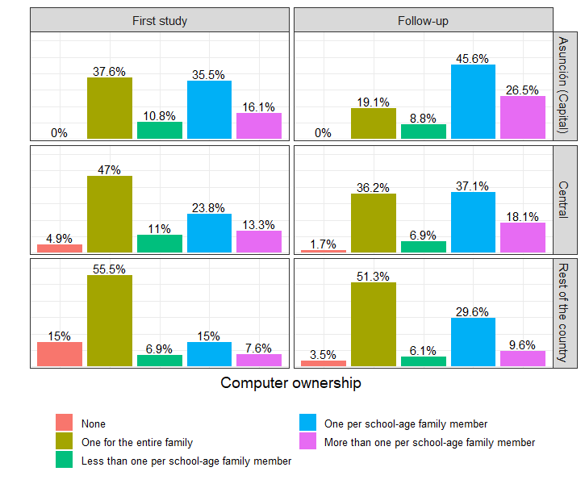
Figure 1: Computer Ownership Household, by Place of Residence

The type of Internet connectivity was one of the aspects that stood out at the end of the 2020 school year, according to the data collected in the study. Figure 2 shows significant increases in the percentage of teachers with unlimited internet connection in Asunción, in the Central Department and in the rest of the country, compared to those observed in the first months of mandatory virtual classes. The largest increase was observed in the rest of the country. However, this does not necessarily mean a good internet connection, as this usually depends on the area of residence. The increase in the percentages of teachers who have unlimited internet connection is consistent with the answers given regarding the acquisition of more internet services. The majority of teachers indicated that more or much more internet connection was required, so they were forced to purchase more internet data. In Asunción, about 50% of the teachers purchased more internet services, as well as almost 70% in the Central department and approximately 75% in the rest of the country.

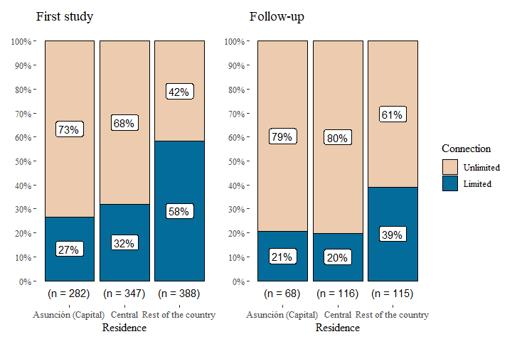
Figure 2: Type of Internet Connection, by Place of Residence

Communication between teachers and students is fundamental to maintain a pedagogical balance and empathy in difficult times such as the COVID-19 pandemic. Teachers used various means of communication with their students, among which WhatsApp stands out. Its widespread use was observed at both times of the study. This messaging service was widely used by teachers throughout 2020 and at all educational levels, even showing an increase at the higher educational level by the end of 2020. Educators teaching in secondary and higher education also expressed, in higher proportions, to be using online educational platforms to maintain communication with their students; however, this communication most likely represented a secondary use of these educational platforms as the main means of communication was the messaging application. Videoconferencing also represented an important means to establish communication with students. The percentages of teachers using videoconferencing at the end of 2020 show an important increase from those observed at the beginning of the pandemic; these differences are as high as 44%. In smaller proportions, email and text messaging were also used, although it is noteworthy that at all levels, except in secondary education for email, higher use was reported at the end of the year (Figure 3).

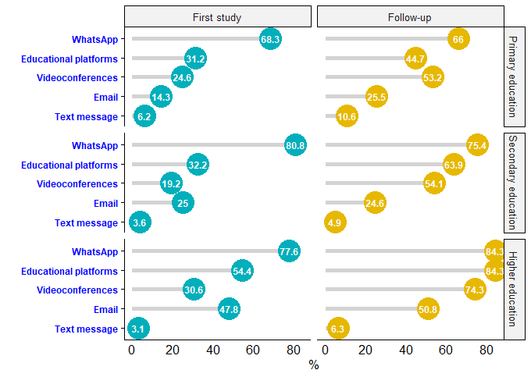
Figure 3: Means of Communication, by Educational Level

The qualitative analysis also indicates that teachers had problems both with access to reliable internet connection, access to technological devices to participate in classes as well as access to proper infrastructure provided by the school. For example, some answers given by teachers highlight main difficulties such as “lack of resources of teachers and students in terms of access to technological tools and internet service”, as well as problems such as “lack of access not precisely for lack of signal but for lack of economic resources.” Teachers also mentioned that they noticed students do not possess enough technological knowledge or that schools provide a very basic internet service which does not meet the teachers or students’ needs. Some answers indicate that "the biggest challenge is to make quality education accessible to all. There is no good internet service and it is expensive, and school students have little or no instruction in the use of ICTs for educational purposes” as well as “it is difficult to learn when, even if teachers and students have connectivity and equipment, [as] the institution's platform is down because the "basic package" that only allows 10 simultaneous connections has been contracted.”

In every educational level, different types of didactic materials or resources were proposed, both at the beginning of the virtual classes and at the end of the 2020 period. According to the teachers' responses, almost all of these resources or materials experienced an increase in their use until the end of the school year. Video tutorials and reading materials (pdf and/or PowerPoint) are the most used in the three educational levels considered in the study. However, at the primary level, the use of interactive materials also stood out. This may be due to the fact that in primary education a different dynamic is required as opposed to the higher levels due to the nature of the school cycle and of the children who are, in many cases, just beginning their education. In not negligible proportions, teachers also reported the use of chat rooms and suggested searching for information by visiting specialized web pages or pages on general topics (Figure 4).

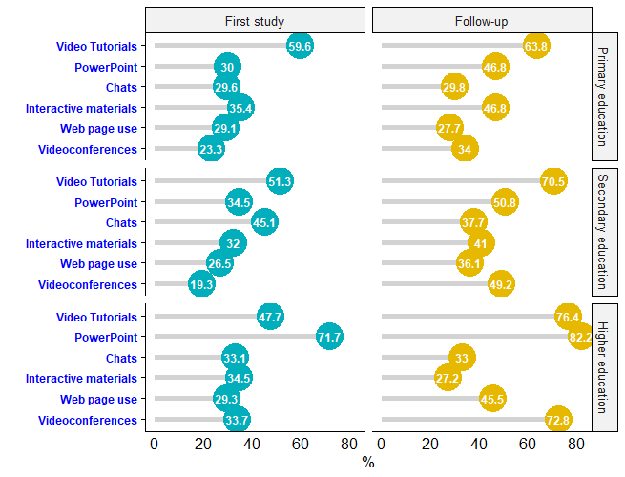
Figure 4: Educational Materials Used, by Education Level

Professional Development and Teacher Training

Since the use of technological tools for the adequate development of educational activities was essential, teachers were forced to receive training in the use of these tools. Table 1 shows that before the quarantine and even after it was declared, in the first study, high percentages of teachers had not received any type of training in the use of technology. However, in the follow-up study this percentage decreased considerably. Thus, this study found that approximately 90% of the teachers received training in the use of ICTs for at least 3 hours.

Table 1: ICT Training Before and During the Pandemic (%)

 | Before quarantine |  | During quarantine
ICT training time | First study | Follow-up | First study | Follow-up
Never | 32,6 | 22,4 | 47,6 | 12,4
3 hours or fewer | 19,7 | 17,7 | 30,6 | 17,1
More than 3 and less than 10 hours | 17,5 | 18,1 | 13,7 | 24,1
From 10 to 40 hours | 12,2 | 19,4 | 6,2 | 19,1
More than 40 hours | 18,0 | 22,4 | 1,9 | 27,4
Total | 100 | 100 | 100 | 100

The fact of receiving ICT training reflects to some extent the level of competence in relation to computer technologies. In the first study, only about 42% of the teachers expressed that their competence levels were between advanced and expert. However, as the months went by and with the gradual appropriation of ICT in teaching, almost 70% of the teachers rated themselves at the advanced and expert levels in relation to computer technologies. The description of these two levels, as well as the others, are described in Table 2.

Table 2: Level of Teaching Competence in Relation to ICT (%)

Level of competence in relation to computer technologies | First study | Follow-up
Unknown: I have no experience with information technology. | 2,1 | 0,7
Newcomer: I have tried to use computer technologies, but I still need help on a regular basis. | 12,1 | 6,7
Beginner: I can perform basic functions in a limited number of computer applications. | 44,2 | 23,1
Advanced: I have acquired the ability to competently use a wide range of computer technologies. | 37,1 | 58,9
Expert: I am extremely proficient in the use of a wide variety of computer technologies. | 4,5 | 10,7
Total | 100 | 100

With respect to teacher training there were several answers in relation to the lack of training received from schools and also training teachers participated in on their own?. Some answers related to this topic highlight the fact that the curriculum is not designed to be taught completely online: “The curriculum is not designed or developed for virtual classes” hence there is a need to have “governmental and private institutions to invest in training” since it nowadays a necessary skill to master. Others mentioned that it is necessary to “​​overcome the lack of knowledge of educational technology” due to the fact that “technological tools are a necessity nowadays.” Some teachers had to learn to use ICT on their own since according to them the MEC training was not enough, on this note, a teacher mentioned “I learned much more from the pandemic (by necessity and implementation) than from the MEC training.” Despite the increase in the level of familiarity with ICT that is noted in the quantitative results, it is important to mention that the open questions shed some light on the difficulties and challenges that teachers had to go through in order to improve their skills in the use of ICT in the classroom.

ICT Use, Integration and Teaching Methodologies

During the first months of distance classes to address the need to provide continuity to the educational process, only teachers who are in higher education responded that they were using technological tools for the development of their activities almost always or always. Depending on the level in which the teacher works, the appropriation of technology and its use may be different, since it is not the same to teach children at the initial levels as it is to teach adolescents or adults at the higher levels of secondary or university education. However, frequent use increased significantly by the end of 2020, according to reports given by teachers at the three educational levels studied. The increase in the use of technological tools was most notable in primary education teachers (Figure 5).

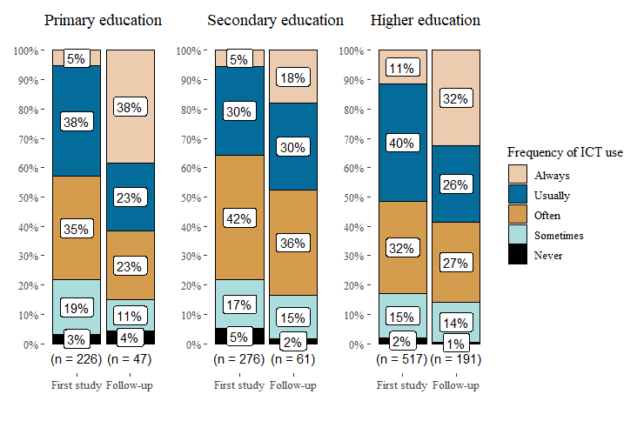
Figure 5: Frequency of ICT Use, by Level of Education

Table 3 shows the different stages related to the process of ICT integration in teaching, as well as the evolution experienced by teachers with respect to these stages before and at the beginning of the quarantine, and in the follow-up study. The most advanced stages, such as Adaptation and Creative Application, were again highlighted. Before quarantine there was a higher proportion of teachers who felt they were in the early stages such as Awareness, Learning, Understanding compared to the Adaptation and Creative Application stages. Each stage related to the process of integrating ICT in teaching is detailed in Table 3.

Table 3: Stages of ICT Integration, Before and During Quarantine (%)

 | Before quarantine |  | During quarantine
Stages related to the process of integrating ICT in education | First study | Follow-up | First study | Follow-up
Awareness: I am aware that technology exists, but I have not used it, perhaps I am even avoiding it. The possibility of using computers makes me anxious. | 13,7 | 2,0 | 4,4 | 1,4
Learning: I am currently trying to learn the basics. I sometimes get frustrated using computers and lack confidence when using them. | 16,6 | 4,4 | 15,6 | 5,4
Understanding: I am beginning to understand the process of using the technology and can think of specific tasks where it might be useful. | 17,0 | 9,1 | 14,9 | 6,8
Familiarity: I am gaining a sense of self-confidence in using the computer for specific tasks. I am starting to feel comfortable using the computer. | 16,0 | 17,2 | 19,3 | 11,2
Adaptation: I think of the computer as an instructional tool to help me and no longer worry about it as technology. I can use many different computer applications. | 10,0 | 27,7 | 10,4 | 28,9
Creative application: I can apply what I know about technology in the classroom. I can use it as an instructional aid and have integrated computers into the curriculum. | 26,7 | 39,5 | 35,5 | 46,3
Total | 100 | 100 | 100 | 100

With respect to the teaching methodology preferred by the teachers, no significant differences were found between the statements collected in the first study and in the follow-up. The proportions remained almost constant from one period to the next. Approximately half of the teachers indicated that they prefer to balance evenly between teacher-directed and student-centered activities. Low percentages of teachers were seen who prefer a methodology that is largely teacher-directed or at least more teacher-directed than student-centered (Table 4).

Table 4: Teaching Methodology Preferred by the Teachers (%)
Preferred teaching methodology | First study | Follow-up
Largely teacher-directed (e.g., teacher-led discussion, masterclass) | 7,3 | 8,7
More teacher-centered than learner-centered | 5,0 | 3,3
Even balance between teacher-centered and student-centered activities. | 50,7 | 47,8
More learner-centered than teacher-centered | 13,6 | 17,1
Largely learner-centered (e.g., cooperative learning, discovery learning) | 23,4 | 23,1
Total | 100 | 100

In the two stages of the study, the vast majority of teachers (78.3% in the first study and 85.6% in the follow-up) reported having some difficulty in coping with the continuity of education through digital media. However, difficulties such as lack of knowledge in the use of ICT, lack of access to technological tools, lack of technical support, lack of institutional support and lack of access to teaching materials decreased greatly by the end of 2020, although these did not represent major difficulties at the beginning of the disruption. However, there was a significant increase in problems related to internet connection (Figure 6). Although there was a greater acquisition of the Internet, this did not prevent problems with the connection.

The time allotted to lesson planning and homework corrections were other aspects highlighted in the research. In the first stage of the study, around 60% of the teachers indicated that the time dedicated to lesson planning increased to some degree. In the follow-up, this percentage reached almost 80%, with more than half of the teachers reporting a significant increase in planning time. As for the time dedicated to correcting activities, a little more than half of the teachers expressed an increase in the time dedicated to this task, at the first moment. Again, at the end of 2020, higher proportions of teachers reported that the time taken to correct their students' activities increased slightly or significantly. Almost 58% responded that the increase in correction time was significant (Table 5). These discrepancies were significant at X² = 43.9 and p<0.001.

Table 5: Time for Class Planning and Correction of Activities (%)
 | Time for planning |  | Time for homework checking
 | First study | Follow-up | First study | Follow-up
Has decreased significantly | 5,6 | 2,7 | 10,9 | 2,0
Has decreased slightly | 12,6 | 5,0 | 14,5 | 5,0
Has remained unchanged | 20,3 | 13,7 | 21,6 | 12,7
Has increased slightly | 25,5 | 23,1 | 23,9 | 22,4
Has increased significantly | 36,0 | 55,5 | 29,1 | 57,9

Difficulties Encountered, Satisfaction and Opportunities

Teachers were also asked about their perceptions of possible difficulties their students might experience, according to what they observed throughout the academic development. The responses were varied in this aspect, with the opposite being noted in terms of the evolution of difficulties between teachers and students. Some of the minor difficulties seen in the students in the first study and which were more insistent at the end of the 2020 school year were lack of interest, lack of motivation and lack of time. The biggest problem observed at the beginning of the restrictions was that of internet connection. From 53.1% of teachers who said they saw that their students had internet connection problems at the beginning, it escalated to almost 70% of teachers in the follow-up study (Figure 7).
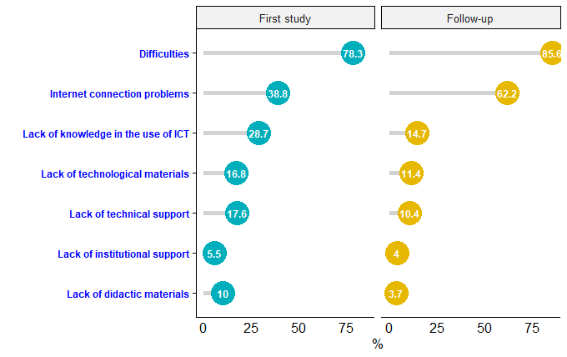
Figure 6: Difficulties Presented in the Virtual Educational Process

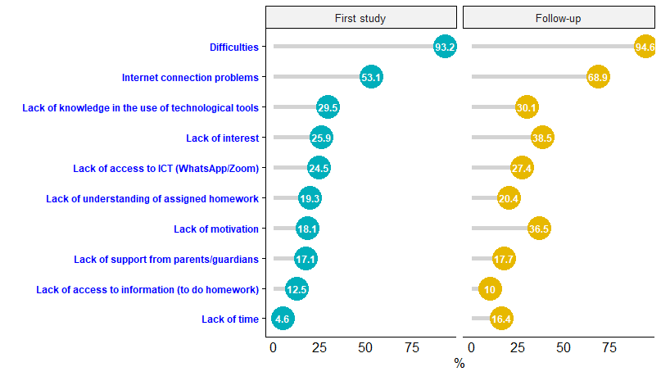
Figure 7: Difficulties Observed in Students During Virtual Classes

Figure 8 shows the satisfaction levels of teachers with respect to ICT implementation in 2020, broken down by place of residence. This item was included in the follow-up study at the end of 2020. In general, the responses given by teachers were mostly concentrated in the categories "Satisfied" and "Fully satisfied" in each of the places of residence. Overall, between 72% and 83% of teachers were positive about the continuity of education through technological tools. In spite of all the situations experienced by the teachers in the distance teaching-learning process, there was a conservative stance regarding the continuation of virtual or technology-mediated classes in 2021. More than 67% of teachers in each location agreed or strongly agreed with this way of beginning classes the following year (Figure 9). This was largely due to the fear of returning to classes with the epidemiological situation in the country, since at that time the pandemic situation in the country was very complex.
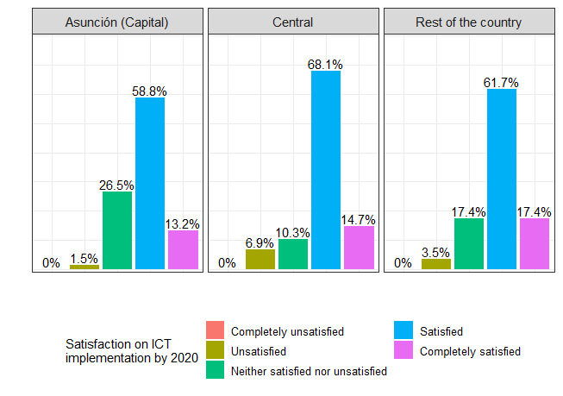
Figure 8: Level of Satisfaction with the Implementation of ICT

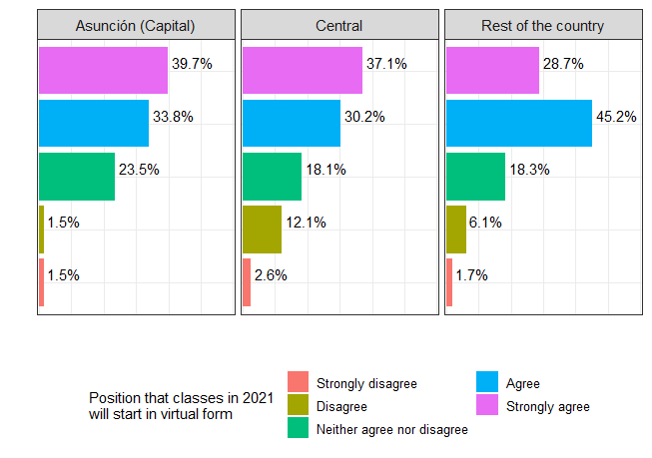
Figure 9: Opinions about starting 2021 with virtual classes

The qualitative answers given by the teachers also indicate there were many difficulties faced during the implementation of virtual learning, that is besides the difficulties related to internet access and lack of technological resources mentioned above. Answers provided by the teachers involve topics such as student motivation and engagement in the class: "More than academics, the biggest challenge was to keep the students motivated and also socialized in some way through the virtual classes...the emotional was mostly a priority” and "Challenges: keep the group of students interested and motivated by working cooperatively.” Other teachers expressed that students had problems comprehending assigned tasks by stating that a difficulty is “reaching the student's understanding of certain content, maintaining constant motivation in students” and emphasized the need to focus on emotional health: “The main challenge is to maintain emotional balance.”

Moreover, the situation also led some teachers to see the implementation of ICT as an opportunity to adopt new teaching strategies and learn to utilize technological tools effectively. Such answers indicate that “Opportunities for me are many: the transition from face-to-face to virtual education, the adaptation of most of the students, the supportive role in the completion of homework on the part of parents, among others.” Some teachers felt that they are now better prepared in the use of technological resources due to the situation presented by the pandemic expressing: “I think I am more prepared for virtual teaching considering the 2020 experience and the personal trainings I did, and also my self-management to reach the knowledge I have achieved today” and “The challenge was to motivate students to get involved and interact in class every day, the opportunities are in continuing to apply technologies even in face-to-face classes, many teachers learned a lot of techniques and methodologies that we will continue to apply.”

Discussion

This follow-up study shows encouraging results concerning several important factors when implementing technological tools for remote learning. Although technological resources for teachers have increased, there are still concerns about education quality, technologic literacy, and an overall feeling of uncertainty towards the future. The study highlights a significant increase in the possession of computers, connectivity and also usage of technological tools; the latter in all levels of education, particularly in primary education. The increase of possession of computers and the access to unlimited internet might have helped teachers make better use of technological tools available to them. In a similar study, Judd et al., (2020) reported that the teachers who had access to more resources tend to feel they are more suitable for online instruction. Concerning the means of communication, the study presents that the most widely used medium for communication between students and teachers is WhatsApp, as well as educational platforms, mainly in the higher education sector. The use of text messaging applications has been reported by other researchers in similar studies in Paraguay (Picón et al., 2020) within a similar context. However, the same authors reported that there was minimal use of WhatsApp among teachers and students whereas text messaging and videoconferences, social networks, and telephone calls were used as the main means of communication. On the other hand, Santos et al. (2020) reported the massive use of WhatsApp among teachers as well as the minimum use of educational platforms for communication purposes. Similarly, Mishra et al., (2020) reported a wide use of WhatsApp among teachers in students in a higher education for communication and academic purposes.

The study also showcased that there was an increase in the use of technology in the classroom, especially in primary education. Such change could indicate the increase in usage of interactive activities for such an age group. Other researchers have reported on the difficulty of online teaching with young students, recommending to keep classes small and approaching learning as interactive as possible. This teaching strategy seems to be appropriate since young children are not suitable for activities such as “typing responses into a chat screen or sharing files with written information” (Kim, 2020, p. 4). Moreover, this author also emphasizes the importance of planning ahead for classes with young learners and also receiving support in order to achieve the desired educational outcomes during these trying times. Additionally, there was a noticeable increase in the use of materials such as video tutorials and also reading materials such as pdfs and presentations, which could represent an increase in workload in this distance modality. Previous studies have also shown that distance education might result in an increase in workload for the teacher (Tomei, 2006; Kenny & Fluck, 2017; Marek et al., 2021; Ramos et al., 2020; Phillips & Cain, 2020; Giovannella, 2020).

Concerning the training received during 2020, it can be noted that there is a significant difference between the beginning of 2020 and the end of the year. This increase in training could be linked to teachers’ use of the aforementioned materials and their readiness or positive attitudes towards their abilities in the use of technological tools as expressed in the results. These results coincide with Almazova et al. (2020) in that teachers’ previous knowledge in the use of ICT influences their readiness to adopt technological tools as well as their positive attitude towards distance learning during the pandemic. However, this study indicates that most teachers had only 3 hours of training by the end of 2020. Similar research by Trust & Whalen (2020) indicates that teachers consider that one-time training might not be enough to gain skills to navigate emergency remote teaching efficiently, rather ongoing training and collaboration with colleagues could be more helpful. On this note, Judd et al. (2020) report that teachers feel that because online learning requires significant adaptations, support is necessary. Likewise, Koptcha (2012) indicates that sustained professional development could result in better use of technological tools in the long term. In a similar study, Picon et al. (2020) reported that the training teachers received during 2020 was adequate considering the context in which classes were developed. This study also shows that teachers prefer to have a balance between student centered and teacher centered classes. Considering the evolution of online learning, some consider that with time, virtual classes will shift from a more teacher-centered to a more student-centered environment encouraging group activities and discussions (Zhu & Liu, 2020).

The study results showcase that there was a decrease of certain difficulties faced during this pandemic. That is, comparing the situation teachers faced at the beginning of 2020 and at the end of the year and the implementation of technological tools for distance learning, most teachers noted that difficulties such as lack of institutional and technical support, lack of access to materials decreased. This is paramount since institutional support is among the most important aspects during this time considering the strategies being implemented in online learning (Almazova et al., 2020). On this note, Lapada et al. (2020) claim that a major difficulty faced by teachers in their study is related to deadlines set by the school administrator as well as communication with their students. Hence, they recommend that schools carefully plan their distance education offer in order to monitor and evaluate their curriculum adequately (Lapada et al., 2020; Yusuf & Ahmad, 2020).

Lack of motivation and also lack of knowledge to use ICT for academic purposes were some of the major difficulties that teachers perceived students to have. Such results coincide with previous studies which claim that students lack motivation to study online, lack the skills need for e-learning (Almazova et al., 2020; Yusuf & Ahmad, 2020) and both students and teachers lack reliable internet connection to complete assignments or engage in class (Trust & Whalen, 2020; Judd et al., 2020; Yusuf & Ahmad, 2020). Considering this point, teachers agree that “conventional teaching competencies and skills do not guarantee the success of the online educational process” (Almazova et al., 2020, p. 6). Similarly, other difficulties include the feelings of uncertainty of what is to come. This can be noted in the qualitative answers and it represents an important aspect of teaching during a crisis. Hadar et al. (2020) have also noted that teachers and students have a feeling of overall uncertainty towards the situation which led teachers to adapt the curriculum to fit students’ needs and focus more on the personal well-being and on relationship building.

Despite the difficulties faced by educators during the year 2020, the opportunity for professional development and the intellectual challenge presented by the use of new technological tools are advantages identified by teachers (Amazova et al., 2020). Moreover, the study shows that teachers were satisfied with the measures taken to ensure the continuity of the education process. Such results coincide with Hebebci et al., (2020) since they report that teachers had positive opinions regarding the implementation of virtual learning in the face of confinement. Although virtual learning has its disadvantages, it was the best strategy implemented to continue education since there was no other alternative in sight (Hebebci et al., 2020). Moreover, the qualitative answers indicate that some teachers have also embraced this situation and consider it as an opportunity to learn and integrate technology into the classroom. Similarly, in other teaching contexts, such as in teacher education programs, the COVID-19 situation was also seen as an opportunity to experiment with technology and to gain autonomy and accountability by using several technological platforms and planning for engaging classes for students (Sepulveda-Escobar & Morrison, 2020).

Conclusion

The present study highlights the changes that took place at the beginning and at the end of 2020 as a consequence of confinement measures due to the COVID-19 pandemic. The results offer a hopeful outlook about the situation teachers faced as they adopted new pedagogical strategies, implemented technological tools massively in their classrooms, and adapted to the abrupt changes that affected the whole of the education system. Overall, the increased possession of technological devices such as computers and smartphones, and the increased access to internet services demonstrate the effort made by professionals to deal with infrastructure challenges presented by their context. Likewise, the increased use of technological tools such as platforms and software in all levels of education are proof of the level of adaptability among teachers. That is, despite the challenge, educators were able to carry out academic activities as instructed by their institutions immediately and throughout the year, they continued reshaping their classes to meet the educational needs of students. The role of teachers has never been more important to maintain the educational system running, and as such, teachers should be supported and accompanied through the process of change and implementation of high-quality distance learning (Zhu & Liu, 2020).

The year 2020 has left important lessons for educators around the world. Research has demonstrated time and again that the pandemic did not only present challenges but also opportunities for reshaping teachers’ knowledge of education and pedagogy. The current situation was seen by some as a great opportunity to find new ways of working, adopting new approaches to pedagogy and re-conceptualizing teacher education programs (Mutton, 2020). However, it is important to acknowledge that difficulties remain and more than ever before efforts need to be made in order to address technology literacy from teacher education as well as address teacher and student technology access gap. Only through careful technology implementation and proper support can distance learning continue to be considered a valid alternative to the current pandemic situation (Hebebci et al., 2020). By comparing the experiences and perspectives of teachers during the beginning of the pandemic and at the end of 2020, it is possible to better comprehend their situation and how confinement and the massive use of ICT in the education system has impacted these educational actors. In this way, we can inform policy makers to better support teachers, students and parents to navigate the transition towards face to face education once the opportunity arises.

Acknowledgments

The authors would like to express their utmost gratitude to all participants who contributed to this study by providing their views and perspectives by completing the questionnaires and/or participating in interviews. We are aware that without their support and collaboration this study would not have been possible.

References

Adedoyin, O. B., & Soykan, E. (2020). Covid-19 pandemic and online learning: The challenges and opportunities. Interactive Learning Environments, 1–13.
https://doi.org10.1080/10494820.2020.1813180

Almazova, N., Krylova, E., Rubtsova, A., & Odinokaya, M. (2020). Challenges and opportunities for russian higher education amid covid-19: Teachers’ perspective. Education Sciences, 10(12), 368. https://doi.org/10.3390/educsci10120368

Álvarez Marinelli, H., et al. (2020). La educación en tiempo de coronavirus: Los sistemas educativos de América Latina y el Caribe ante COVID-19. Banco Interamericano de Desarrollo.

Beaunoyer, E., Dupéré, S., & Guitton, M. J. (2020). COVID-19 and digital inequalities: Reciprocal impacts and mitigation strategies. Computers in Human Behavior, 111, 106424. https://doi.org/10.1016/j.chb.2020.106424

Britez, M. (2020). La educación ante el avance del COVID-19 en Paraguay. Comparativo con países de la Triple Frontera. [Preprint]. https://doi.org/10.1590/SciELOPreprints.22

Bozkurt, A., & Sharma, R. C. (2020). Emergency remote teaching in a time of global crisis due to CoronaVirus pandemic. https://doi.org/10.5281/ZENODO.3778083

Cabero, J., & Valencia, R. (2021). Y el COVID-19 transformó al sistema educativo: reflexiones y experiencias por aprender International Journal of Educational Research and Innovation (IJERI), 15, 218-228 ISSN: 2386-4303. http://doi.org/10.46661/ijeri.5246

Cesco, S., Zara, V., Toni, A. F. D., Lugli, P., Betta, G., Evans, A. C. O., & Orzes, G. (2021). Higher education in the first year of covid-19: Thoughts and perspectives for the future. International Journal of Higher Education, 10(3), 285. https://doi.org/10.5430/ijhe.v10n3p285

CONES. (2021, May 13). Registro Nacional de Ofertas Académicas Presenciales que Aplican Herramientas Digitales de Enseñanza-Aprendizaje. Resolución CE-CONES N° 08 de Fecha 16 de abril de 2020| Consejo Nacional de Educación Superior CONES. Recuperado de https://bit.ly/2RVfD08

Dhawan, S. (2020). Online learning: A panacea in the time of covid-19 crisis. Journal of Educational Technology Systems, 49(1), 5–22. https://doi.org/10.1177/0047239520934018

Giovannella, C., Marcello, P., & Donatella, P. (2020). The effects of the Covid-19 pandemic on Italian learning ecosystems: The school teachers’ Perspective at the steady state. ID&A INTERACTION DESIGN & ARCHITECTURE(S), 45, 264-286.
Hadar, L. L., Ergas, O., Alpert, B., & Ariav, T. (2020). Rethinking teacher education in a VUCA world: Student teachers’ social-emotional competencies during the Covid-19 crisis. European Journal of Teacher Education, 43(4), 573–586. https://doi.org/10.1080/02619768.2020.1807513

Hebebci, M. T., Bertiz, Y., & Alan, S. (2020). Investigation of views of students and teachers on distance education practices during the Coronavirus (COVID-19) Pandemic. International Journal of Technology in Education and Science (IJTES), 4(4), 267-282

Hodges, C., Moore, S., Lockee, B., Trust, T. and Bond, A. (2020), “The difference between emergency remote teaching and online learning”, EDUCAUSE Review, available at: https://er.educause.edu/articles/2020/3/the-difference-between-emergency-remote-teaching-and-online-learning (accessed 12 June 2021).

Judd, J., B. A. Rember, T. Pellegrini, B. Ludlow, and J. Meisner (2020). “This is Not Teaching”: The Effects of COVID-19 on Teachers. Accessed 12 May 2021. https://www.socialpublishersfoundation.org/knowledge_base/this-is-not-teaching-the-effects-of-covid-19-on-teachers/

Kenny, J., & Fluck, A. E. (2017). Towards a methodology to determine standard time allocations for academic work. Journal of Higher Education Policy and Management, 39(5), 503–523. http://doi.org/10.1080/1360080x.2017.1354773

Kim, J. (2020). Learning and teaching online during covid-19: Experiences of student teachers in an early childhood education practicum. International Journal of Early Childhood, 52(2), 145–158. https://doi.org/10.1007/s13158-020-00272-6

König, J., Jäger-Biela, D. J., & Glutsch, N. (2020). Adapting to online teaching during COVID-19 school closure: Teacher education and teacher competence effects among early career teachers in Germany. European Journal of Teacher Education, 43(4), 608–622. https://doi.org/10.1080/02619768.2020.1809650

Koptcha, T. J. (2012). Teachers’ perceptions of the barriers to technology integration and practices with technology under situated professional development. Computers & Education, 59(4), 1109–1121. https://doi.org/10.1016/j.compedu.2012.05.014

Lapada, A. A., Miguel, F. F., Robledo, D. A. R., & Alam, Z. F. (2020). Teachers’ covid-19 awareness, distance learning education experiences and perceptions towards institutional readiness and challenges. International Journal of Learning, Teaching and Educational Research, 19(6), 127–144. https://doi.org/10.26803/ijlter.19.6.8

Marsollier R. & Expósito C. (2021) Estrategias de Afrontamiento implementadas por docentes en situación de pandemia COVID-19. CienciAmérica. 10(1) 35-54. http://dx.doi.org/10.33210/ca.v10i1.357

Marek, M. W., Chew, C. S., & Wu, W. V. (2021). Teacher experiences in converting classes to distance learning in the covid-19 pandemic: International Journal of Distance Education Technologies, 19(1), 89–109. https://doi.org/10.4018/IJDET.20210101.oa3

MEC, Ministerio de Educación y Ciencias. (2020). Plan de Educación en Tiempos de Pandemia "Tu Escuela en Casa" [Ebook]. Asunción. Recuperado de https://www.mec.gov.py/cms_v2/adjuntos/15716?1589908264

MEC, Ministerio de Educación y Ciencias. (2021). Protocolo y guía operativa para el retorno seguro a instituciones educativas 2021. [EBook]. Asunción. Recuperado de https://www.mec.gov.py/cms_v2/adjuntos/16686?1612893715

Mishra, D. L., Gupta, D. T., & Shree, D. A. (2020). Online Teaching-Learning in Higher Education during Lockdown Period of COVID-19 Pandemic. International Journal of Educational Research Open, 1, 100012. http://doi.org/10.1016/j.ijedro.2020.100012

Mutton, T. (2020). Teacher education and Covid-19: Responses and opportunities for new pedagogical initiatives. Journal of Education for Teaching, 46(4), 439–441. https://doi.org/10.1080/02607476.2020.1805189

Phillips, L., & Cain, M. (2020). Exhausted beyond measure”: what teachers are saying about COVID-19 and the disruption to education. The Conversation. https://theconversation. com/exhausted-beyond-measure-whatteachers-are-saying-about-covid-19-and-the-disruption-to-education-143601.

Picón G., de Caballero K., & Paredes N. (2020). Desempeño y formación docente en competencias digitales en clases no presenciales durante la pandemia COVID-19 (online). Scielo PrePrints. Disponible en: https://doi.org/10.1590/SciELOPreprints.778

Ramos, V., García, H., Olea, C., Lobos, K. & Sáez, F., (2020) Percepción docente respecto al trabajo pedagógico durante la COVID-19. CienciAmérica, (9)2, pp. 334-353. http://dx.doi.org/10.33210/ca.v9i2.325.

Sokal, L., Trudel, L. E., & Babb, J. (2020). Canadian teachers’ attitudes toward change, efficacy, and burnout during the COVID-19 pandemic. International Journal of Educational Research Open, 1, 100016. https://doi.org/10.1016/j.ijedro.2020.100016

Tabassum, M., Mannan, S. E., Parvej, M. I., & Ahmed, F. (2021). Online education during covid-19 in Bangladesh: University teachers’ perspective. Aquademia, 5(1), ep21005. https://doi.org/10.21601/aquademia/9611

Tomei, J. (2006). The impact of online learning on faculty load: Computing the ideal class size for online learning. Journal of Technology and Teacher Education, 14, 531-541.

Trust, T., & Whalen, J. (2020). Should Teachers be Trained in Emergency Remote Teaching? Lessons Learned from the COVID-19 Pandemic. Journal of Technology and Teacher Education, 28(2), 189-199. Waynesville, NC USA: Society for Information Technology & Teacher Education. Retrieved May 10, 2021 from https://www.learntechlib.org/primary/p/215995/.

Santos, V., Villanueva, I., Rivera, E & Vega, E. (2020) Percepción docente sobre la educación a distancia en tiempos de covid-19. CienciAmérica 9(1) 126-141. http://dx.doi.org/10.33210/ca.v9i3.352

​​Sepulveda-Escobar, P., & Morrison, A. (2020). Online teaching placement during the COVID-19 pandemic in Chile: Challenges and opportunities. European Journal of Teacher Education, 43(4), 587–607. https://doi.org/10.1080/02619768.2020.1820981

Wozney, L., Venkatesh, V., & Abrami, P. (2006). Implementing computer technologies: Teachers' perceptions and practices. Journal of Technology and teacher education, 14(1), 173-207.

Xie, X., Siau, K., & Nah, F. F.-H. (2020). COVID-19 pandemic – online education in the new normal and the next normal. Journal of Information Technology Case and Application Research, 22(3), 175–187. https://doi.org/10.1080/15228053.2020.1824884

Yusuf, B. N. M., & Ahmad, J. (2020). Are we prepared enough? A case study of challenges in online learning in a private higher learning institution during the covid-19 outbreaks. Advances in Social Sciences Research Journal, 7(5), 205–212. https://doi.org/10.14738/assrj.75.8211

Zhang, W., Wang, Y., Yang, L., & Wang, C. (2020). Suspending classes without stopping learning: China’s education emergency management policy in the covid-19 outbreak. Journal of Risk and Financial Management, 13(3), 55. https://doi.org/10.3390/jrfm13030055

Zhao, Y. (2020). COVID-19 as a catalyst for educational change. PROSPECTS, 49(1–2), 29–33. https://doi.org/10.1007/s11125-020-09477-y

Zhu, X., & Liu, J. (2020). Education in and after covid-19: Immediate responses and long-term visions. Postdigital Science and Education, 2(3), 695–699. https://doi.org/10.1007/s42438-020-00126-3

Author Information
ValentinaCanese   https://orcid.org/0000-0002-1584-7322  Universidad Nacional de Asunción, Paraguay  España 1098 c/ Washington  Asunción, Paraguay  Tel. +595971870700  Fax. +59521207599  vcanese@fil.una.py | Juan Ignacio Mereles  https://orcid.org/0000-0001-7727-8500  Universidad Nacional de Asunción, Paraguay  España 1098 c/ Washington  Asunción, Paraguay  Tel. +595 985 317585  Fax. +59521207599  jimereles@facen.una.py
Jessica Amarilla
https://orcid.org/0000-0003-2928-8936
Universidad Nacional de Asunción, Paraguay
España 1098 c/ Washington
Asunción, Paraguay
Tel. +595 961 848888
Fax. +59521207599
isl-jamarilla@fil.una.py

